Employee Name:
Position:
Date:

Growth

Where have you grown the most and found the most success over the past year in your role?

- [please list]

What skill(s), attributes, knowledge bases(s) would you like to strengthen over the next year?
When planning, keep in mind: Specific, Measurable, Achievable, Realistic, and Time-based
Copy chart as needed

Skill/Attribute/Knowledge base:
SLCC Value:
Description:
Planning Milestones:
Any metrics involved:

Planning

How do the plans align with the department/college efforts?

- [please describe]

Support

What can I do as a supervisor to assist you in these efforts?

- [please list]

Do you have what you need to perform your GPS and/or job successfully?

- [please list]

Goals

Professional Development:

- [please list training, certifications, conferences, leadership opportunities, committees, search teams, professional organizations, presentations, mentoring, volunteering, networking, etc. Take a step further and have a plan of action for the professional development]

Current Projects

- [optional section--please list if you would like to include]

Previous Projects Completed

- [optional section--please list if you would like to include]

Considering the ratings below – how would I rate my work performance in the last 6 months? (please explain below)

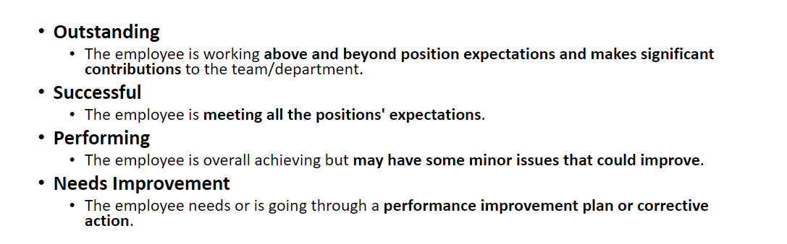

This document (GPS template) is a working document between the employee and the supervisor for your department records. Please remember, the employee needs to submit the GPS Acknowledge Etrieve form for the two GPS meeting held between the employee and Supervisor. The Supervisor will approve the form and it will route to the personnel file.

