February 2020

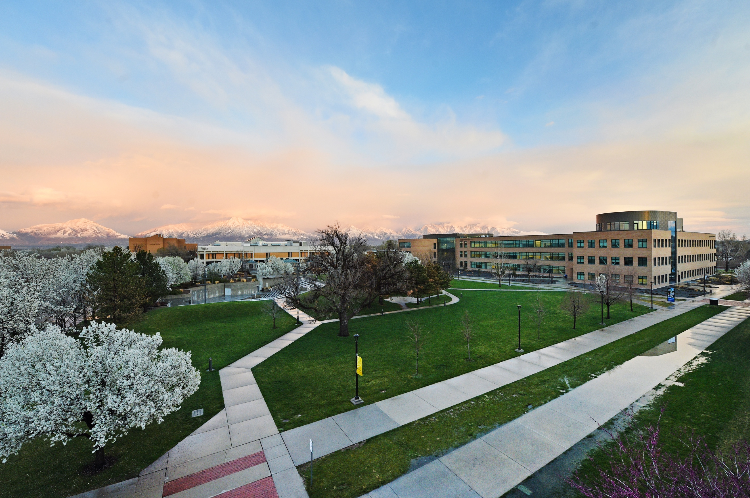

media Report
News Coverage

Summary
416 stories in national and local media. An estimated 857,419 people had subscriber access (reach) to these articles with an estimated earned media value of $331,950.43.

Press Releases

February 7, 2020

“The Musical of Musicals (The Musical!)” Plays for Laughs at SLCC's Grand Theatre

Top Stories

February 2, 2020

One system for all Utah colleges? ‘We need everybody under 1 umbrella,’ lawmaker says DESERETNEWS.com
Career and technical education occurs at the state’s eight technical colleges but also at three colleges and universities that are part of the Utah System of Higher Education: Salt Lake Community College, Utah State University-Eastern in Price and Snow College.

February 4, 2020

SLCC: SUPPORTING UTAH’S ECONOMY THROUGH AFFORDABLE EDUCATION UTAHBUSINESS.com

With a strong economy and hardworking residents, Utah is consistently ranked as one of the best places to live. It’s hard to pick up any publication focused on the economy and not see Utah lauded for our continued job growth and young, growing population. But while there is no doubt that a strong economy produces many positive effects, it does present challenges.

February 8, 2020

SLCC pitcher Joe Barlow invited to Texas Rangers spring training KSL.COM

Riverton native Joe Barlow will be among the pitchers and catchers reporting to spring training on Tuesday, Feb. 11 to compete for a spot in the Texas Rangers bullpen after he was listed as a non-roster invitee of the club.

February 13, 2020

One woman’s journey out of foster care and the daunting task of ‘aging out’ for vulnerable youths DESERETNEWS.COM
Natalie Clark was trembling in the courtroom, though she’d been there many, many times before over the course of her childhood. If everything went well today — “Oh please, let it go well,” she whispered to herself — this would be the last time. This dark-wood and white-walled courtroom had always seemed an almost-happy place where she felt safe though her life in and out of foster care sometimes teetered close to danger.
February 19, 2020

SLCC Business Counseling for Veterans KUTV.COM
Salt Lake Community College wants to make sure we take care of our veterans. Joining us today is Rick Brown sharing more about their Veterans Business Resource Center.

February 20, 2020

How local colleges are boosting Utah's economy KSL.COM
Education drives Utah’s economic growth and promotes a prosperous and equitable society. Salt Lake Community College is at the forefront of that growth by providing skilled workers to fuel job demand statewide. As one of the state’s largest open-access colleges, SLCC’s mission is to help produce a highly trained workforce. This mission guides our decisions in creating programs, curriculum and learning facilities. We partner with local industry and business leaders to understand the skills their employees need, and to align our curriculum accordingly. When our students graduate, they are ready to work and make immediate contributions to the local economy.

February 21, 2020

Exonerated Central Park Five's Yusef Salaam, Raymond Santana are SLCC's 2020 MLK speakers KUTV.COM

Yusef Salaam and Raymond Santana are guest speakers for Salt Lake Community College’s 2020 Martin Luther King, Jr. Commemorative Keynote.

February 21, 2020

5 tips to pick the right college ABC4.COM
Picking the right college can be a tough choice, but it doesn’t have to be. Kate Gildea-Broderic, Director of Admissions at Salt Lake Community College, joined Good Morning Utah to give five tips to help make sure students pick the right school for them.
Media Coverage Analytics
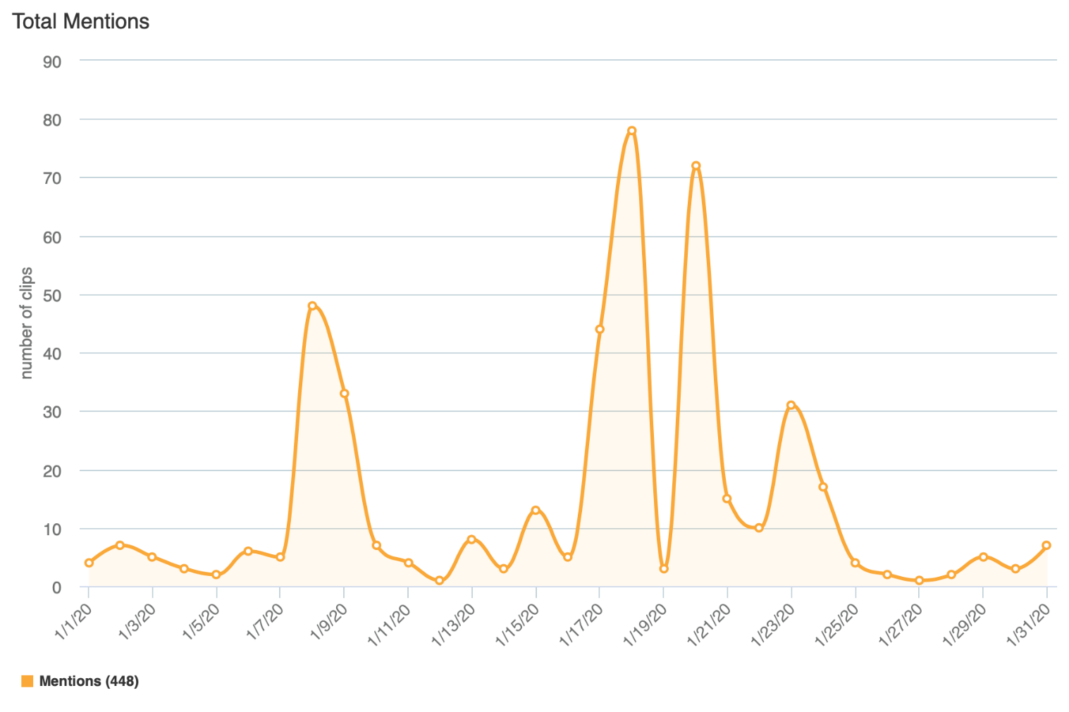

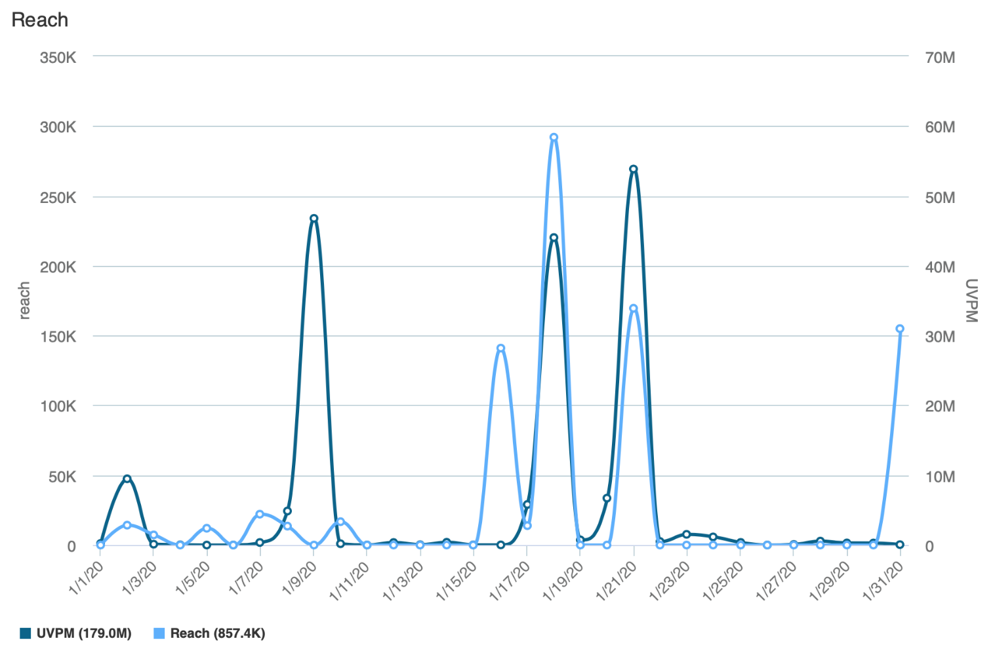
Reach is the Total Number of Unique Viewers/Readers, UVPM is the Total Number of Viewers Across All Social Platforms

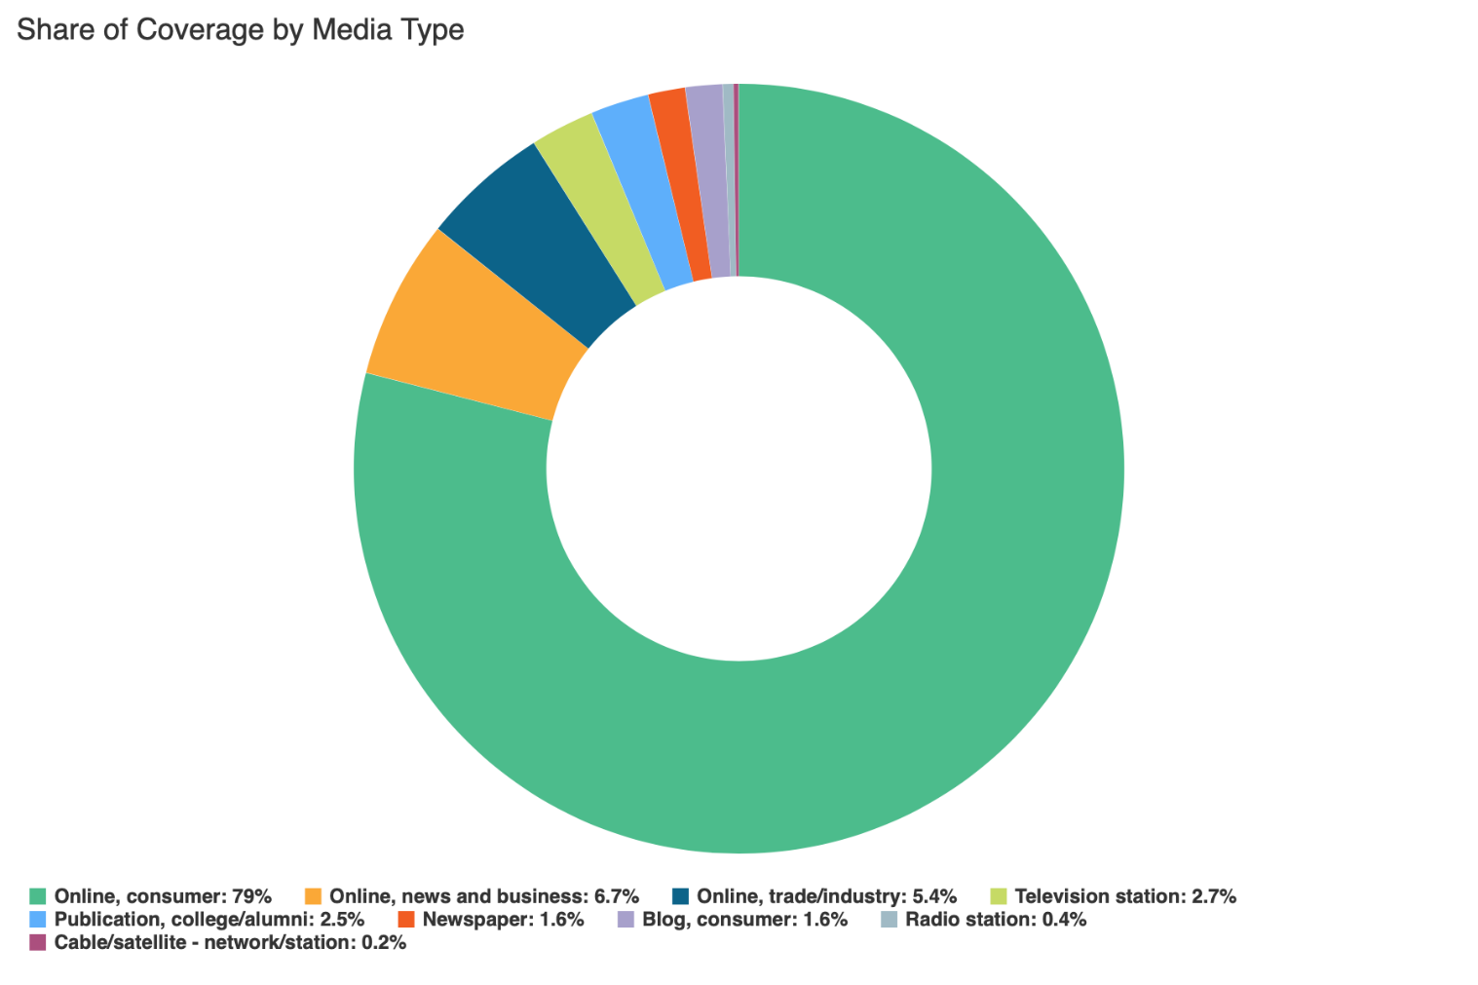

Social Media
SLCC Blog
A total of 7 blog posts were created and placed on the SLCC News and Events Page.
2.5 Student, Alum Tap Into Sundance’s Reservoir of Opportunities
Promoted on Twitter, LinkedIn, SLCC Today

2.5 Students Flock to Metal Sculpting Course for Skills, Artistic Outlet
Promoted on Twitter, LinkedIn, Facebook, SLCC Today

2.6 “The Musical of Musicals (The Musical!)” Plays for Laughs at the Grand
Promoted on Twitter, Facebook, SLCC Today

2.10 Meet Our Faculty: Kit Gidding
Promoted on Twitter, LinkedIn, Facebook, SLCC Today

2.13 True Grit: 16-Year-Old Girl Pursues Diesel Mechanic Path
Promoted on Twitter, LinkedIn, Facebook, SLCC Today

2.19 Deaf Student Seeing Her Way Toward A New Career
Promoted on Twitter, LinkedIn, Facebook
2.28 Coronavirus Information and Resources
Promoted on Twitter, LinkedIn, Facebook, Instagram

Twitter
Number of tweets: 26
Tweet impressions: 171K
Number of mentions: 123
Follower Count: 4231 (+116)
Top Tweet: Top Mention:
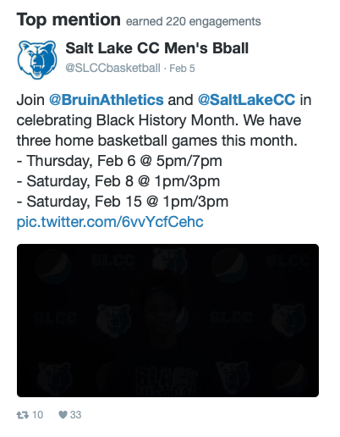
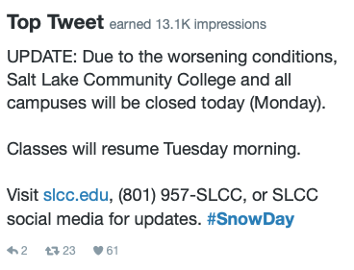

Top Media Tweet:
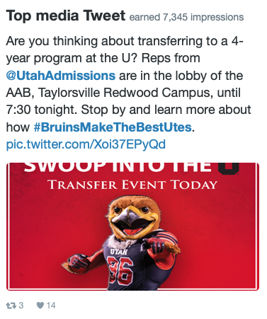

Facebook
Number of posts: 14
Post impressions: 105K
Page likes: 20,531 (+174)
Top post:
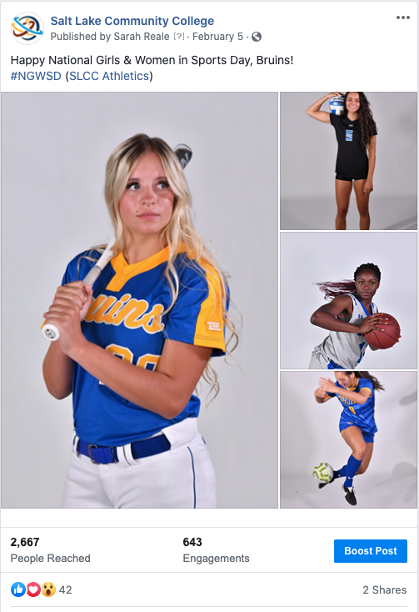

LinkedIn
Number of posts: 4
Page views: 1104
Unique visitors: 640
Total followers: 60,730 (-43)
Likes: 161
Comments: 7
Shares: 5
Top Post:
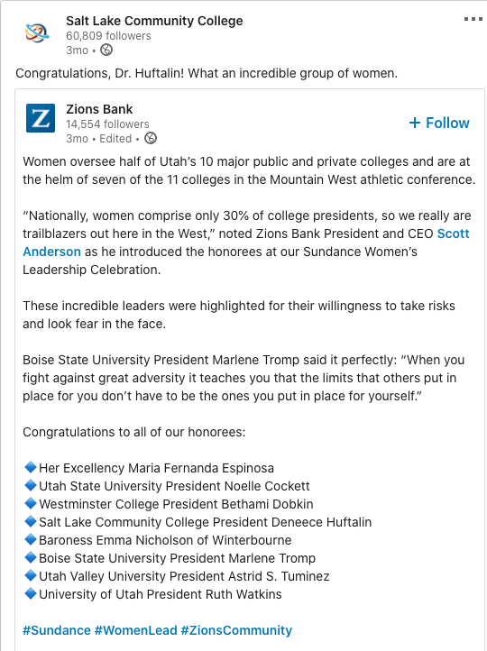

Instagram
Number of posts: 2
Number of stories: 24
Post likes: 215
Total followers: 3236 (+142)
Top post:
