March 2020

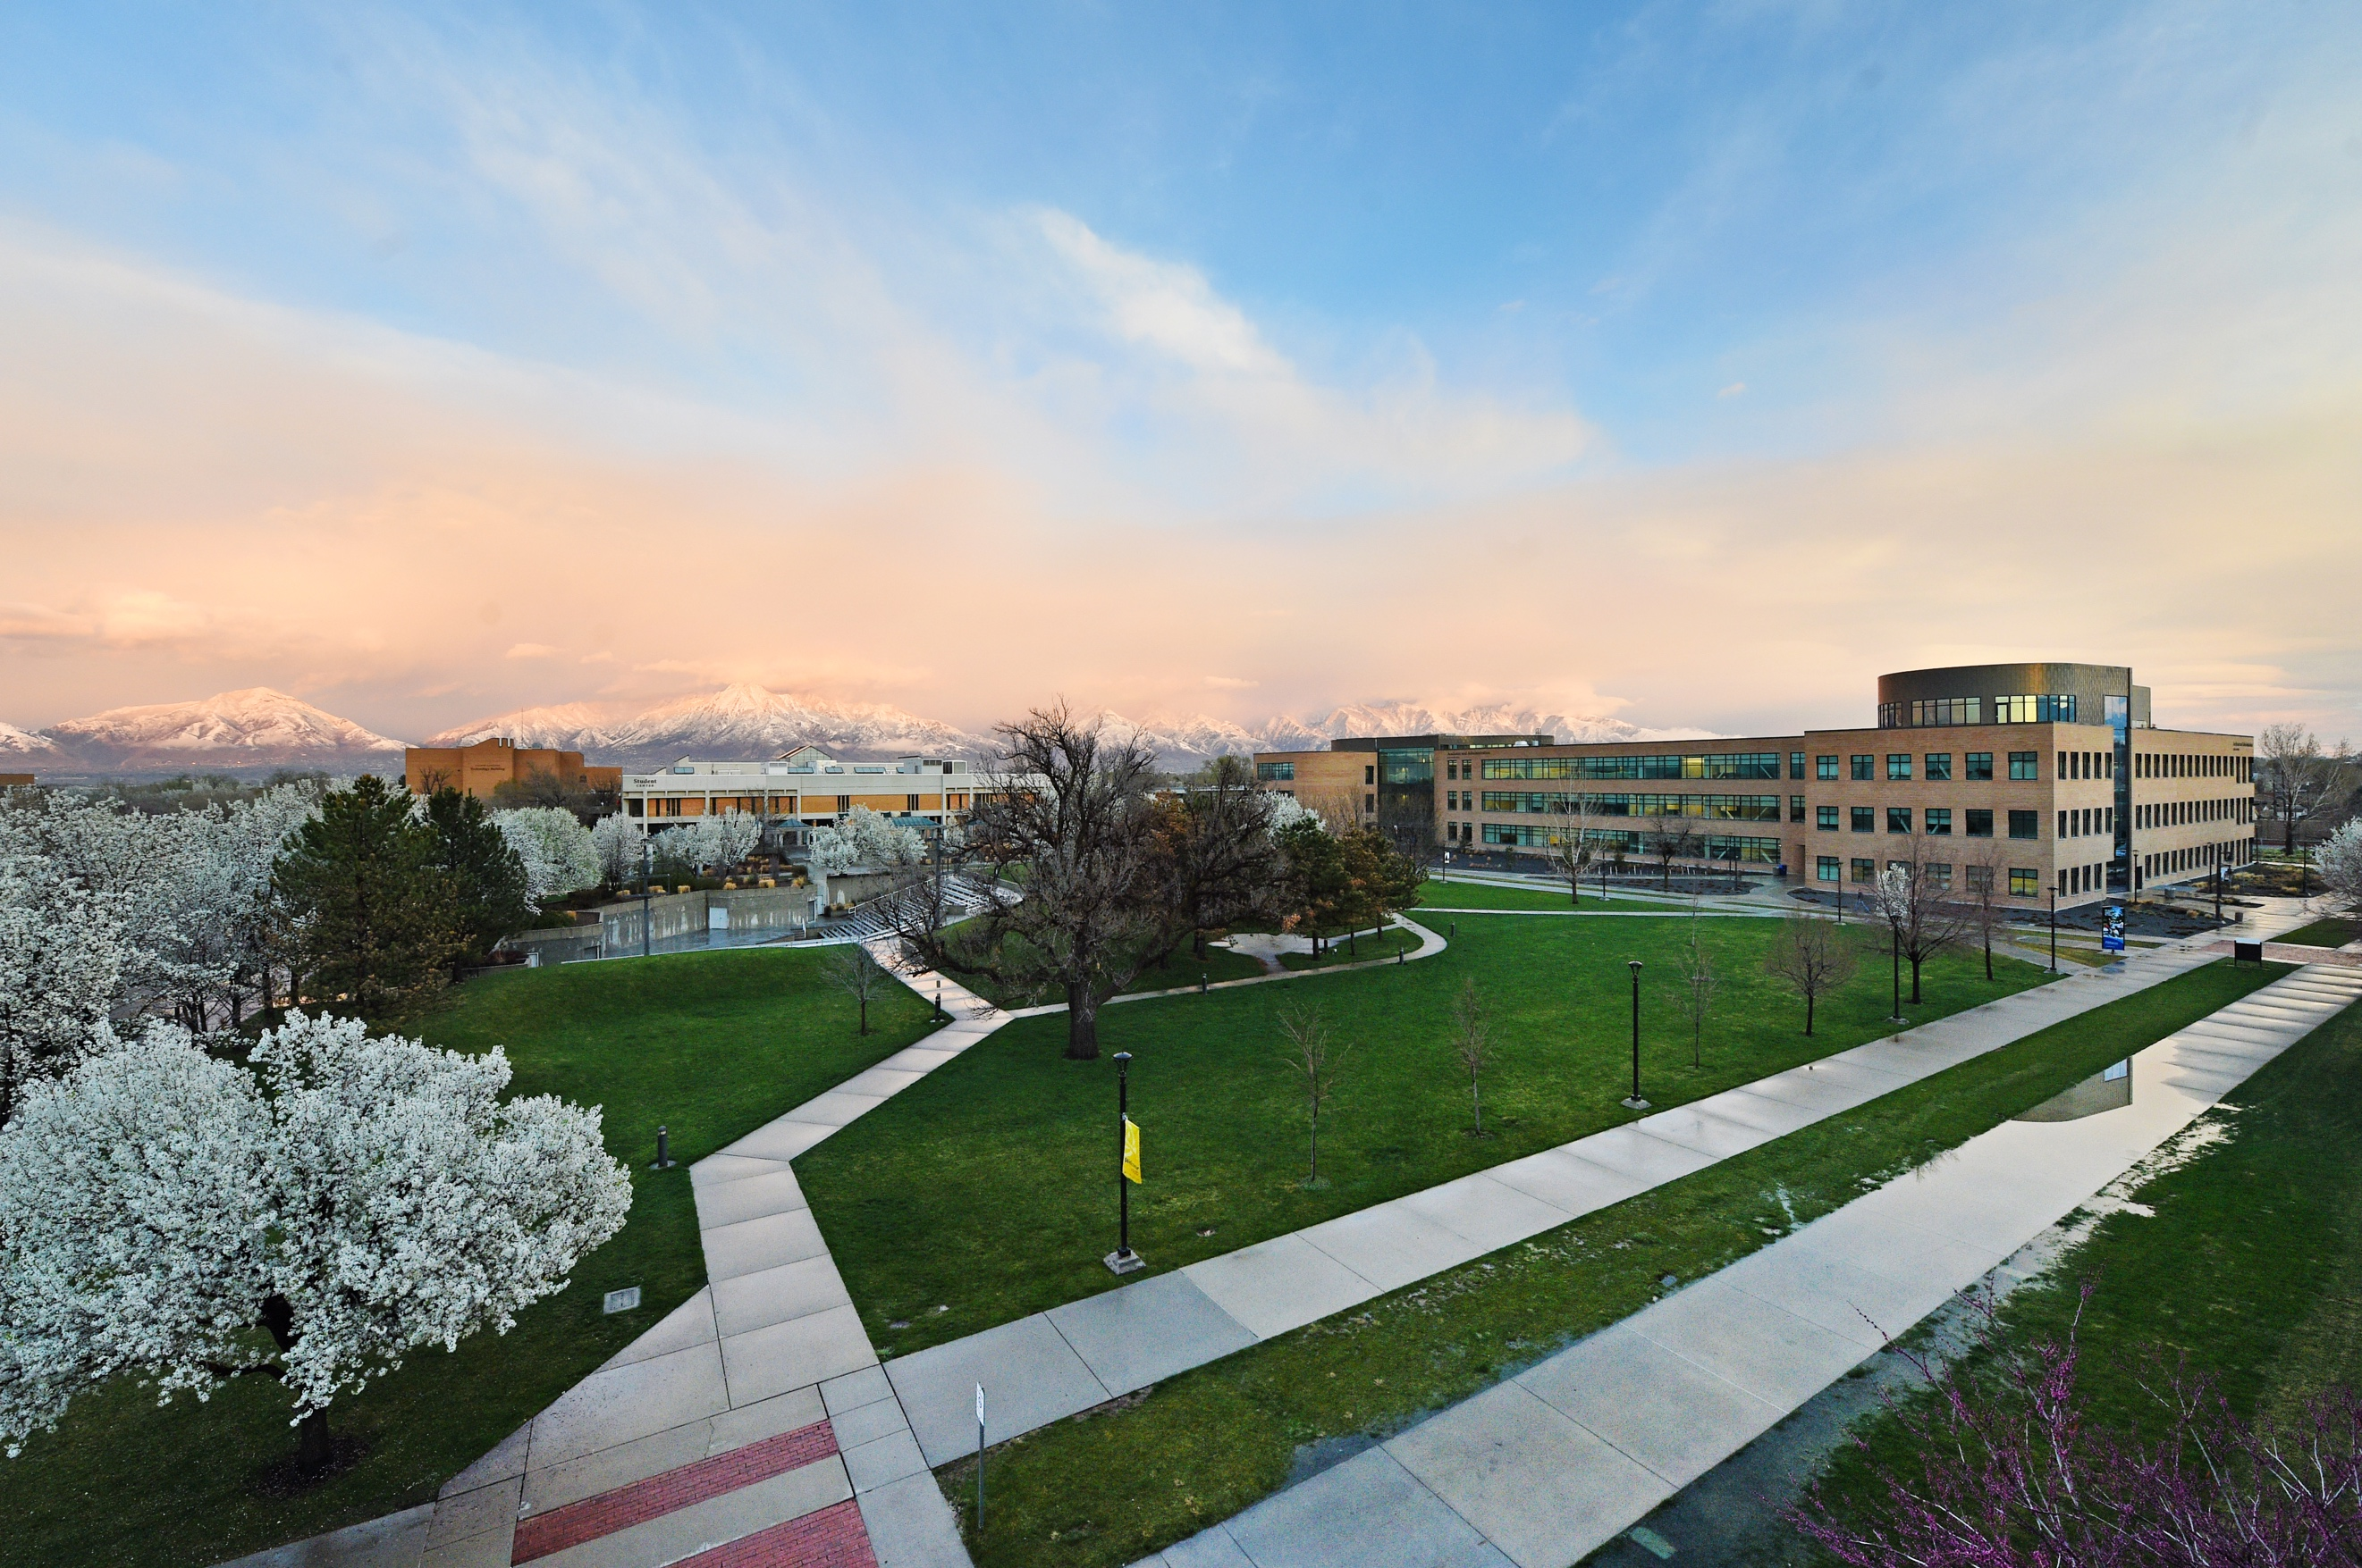

media Report
News Coverage

Summary
342 stories in national and local media. An estimated 3,353,664 people had subscriber access (reach) to these articles with an estimated earned media value of $340,786.46.

Media Advisory

March 18, 2020

SLCC Earthquake Closure (Press Calls, Media Advisory)

March 11-18, 2020

SLCC Transition to Online Classes (Press Calls, Media Advisory and USHE Support)

Top Stories

March 2, 2020

Welding is becoming a career for women FOX13NOW.COM

More women are choosing careers that are typically male dominated. One of those fields is welding. Salt Lake Community College has seen an increase in women enrolling in their welding program.

March 8, 2020

South Jordan teen plans career as diesel mechanic KSL.COM
A Salt Lake County teen is taking a career path that may seem unexpected for many young girls. She’s an aspiring diesel mechanic. The decision has helped her earn a couple of scholarships. Put your mind to it and you can do anything. You’ve heard the saying before. Hailey Brohamer took that “can do” attitude straight to the diesel shop.

March 8, 2020

SLCC head coach Kyle Taylor joins Real Sports Live ABC4.COM
In his first year at the helm, Kyle Taylor has led the Salt Lake Community College men’s basketball team to an already outstanding season. Taylor has led the Bruins to a #5 national ranking, a 29-4 record and into the NJCAA playoffs, which begin next week in Hutchinson, Kansas.

March 9, 2020

SLCC basketball teams selected to NJCAA National Tournament KSL.com
The men’s and women’s basketball teams at Salt Lake Community College both received selections into the NJCAA National Tournament Monday, with both team’s head coaches leading the Bruins to continued success in their first years on the job.

March 10, 2020

Will Utah colleges shift to online instruction in the wake of COVID-19 outbreak? DESERET.com
At Salt Lake Community College, the COVID-19 outbreak is adding new dimensions to Claire Peterson’s role as an assistant professor of humanities. She’s prepared to shift to online instruction for the remainder of spring semester if it becomes necessary due to the novel coronavirus outbreak.
March 18, 2020

Utah’s 8 public colleges cancel or postpone their graduation ceremonies due to coronavirus SLTRIB.COM

Graduation ceremonies have been canceled or postponed at all of Utah’s public colleges and universities as the coronavirus pandemic worsens and restrictions on large gatherings tighten even more in response.

March 19, 2020

Utah universities cancel, postpone graduation ceremonies amid pandemic DESERETNEWS.COM

All Utah public colleges and universities will either postpone or cancel their spring 2020 commencement ceremonies, according to an announcement Wednesday by the Utah System of Higher Education.

March 26, 2020

Utah’s public colleges will see tuition increases this year — despite coronavirus concerns SLTRIB.COM
Despite concerns over the appropriateness of raising tuition during the coronavirus pandemic, the state’s higher education board moved forward Thursday in approving hikes at seven of the eight public colleges in Utah.
Media Coverage Analytics
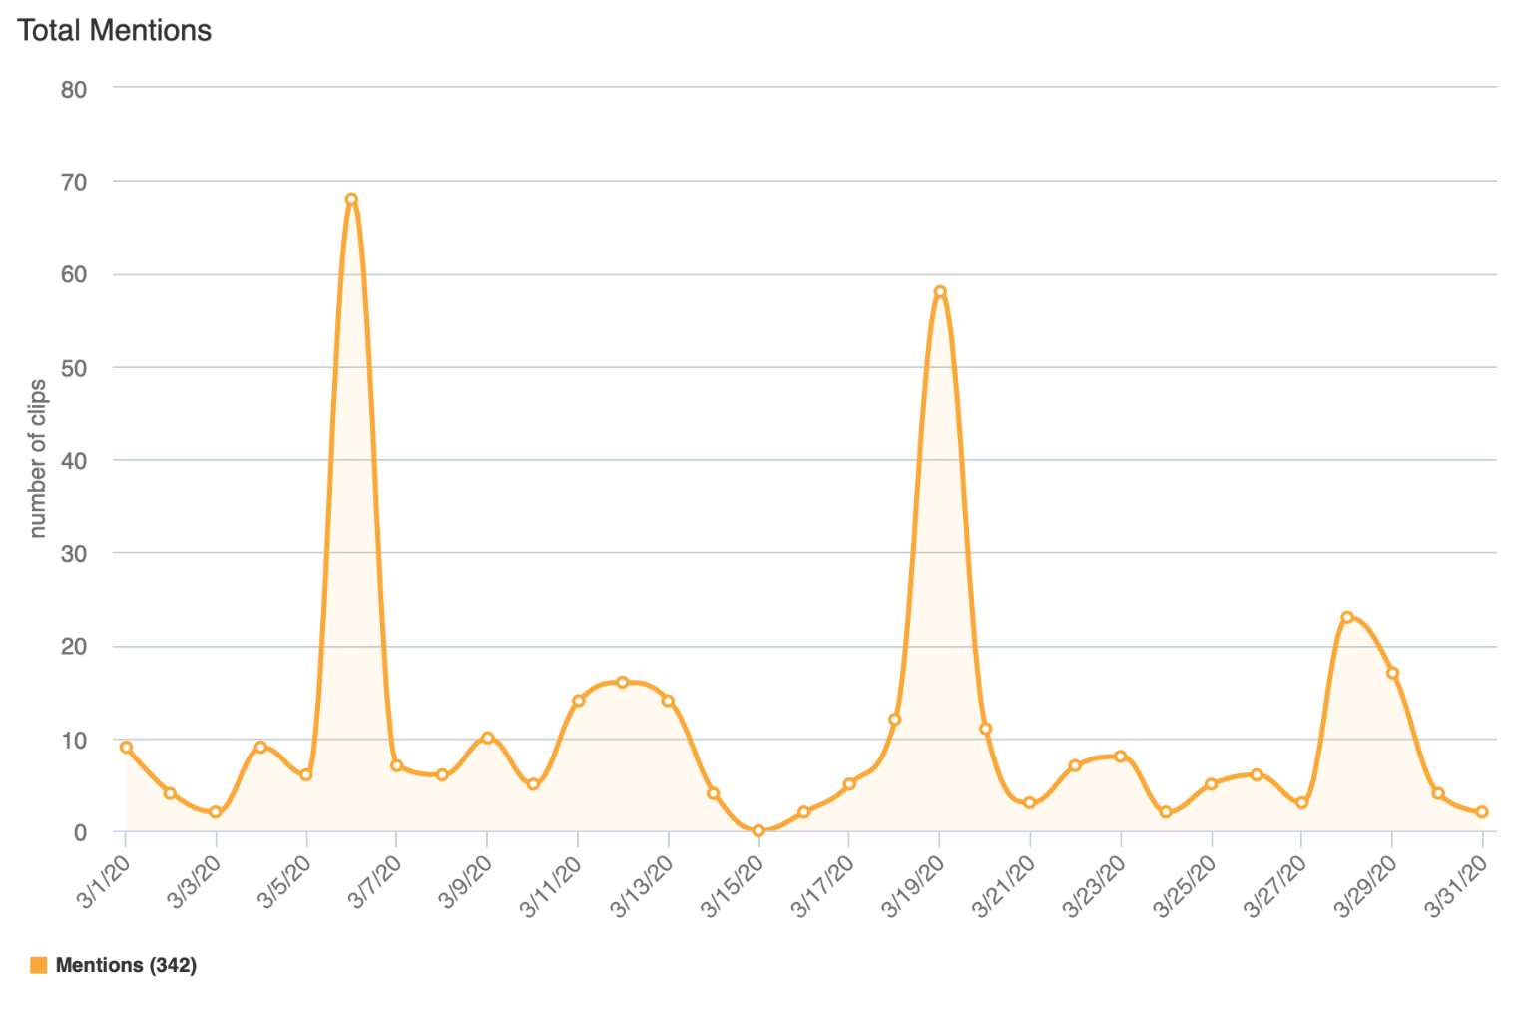

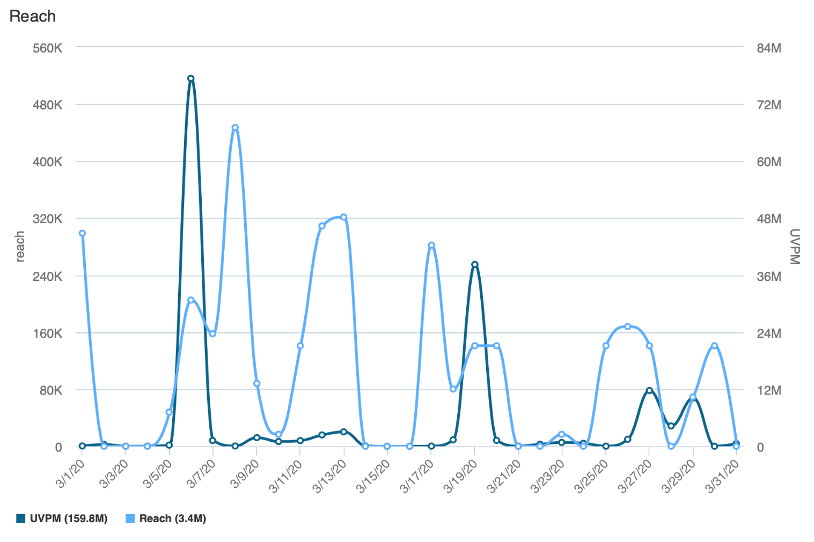
Reach is the Total Number of Unique Viewers/Readers, UVPM is the Total Number of Viewers Across All Social Platforms

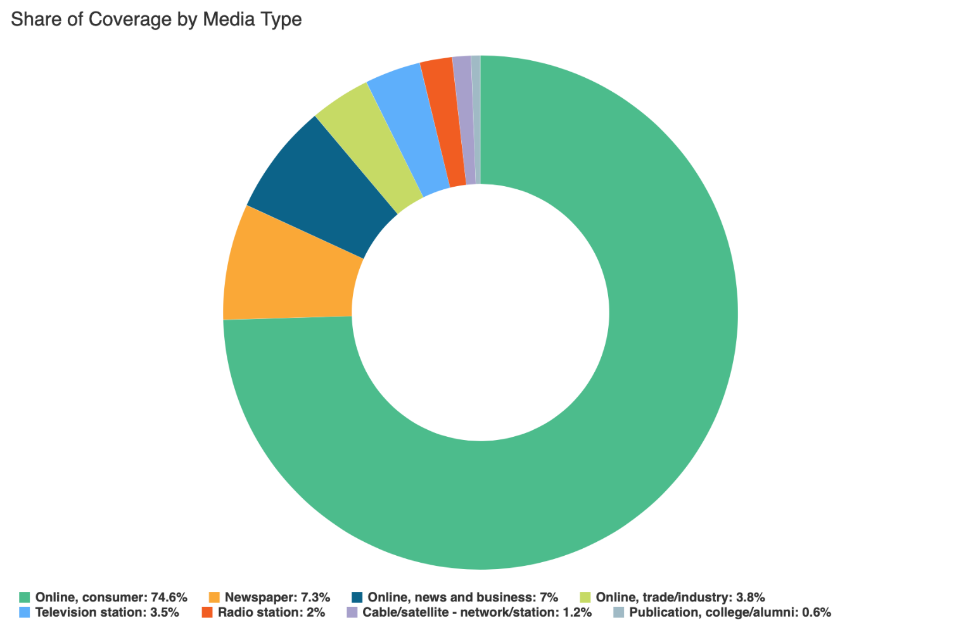

Social Media
SLCC Blog
A total of 10 blog posts were created and placed on the SLCC News and Events Page.
3.1 SLCC Womxn’s History Month Events
Promoted on Twitter, Facebook, Instagram, SLCC Today

3.5 Students Inspire Donors at Annual Scholarship Gathering
Promoted on Twitter, Facebook, SLCC Today

3.6 SLCC President Crowns Student, New Miss Wheelchair Utah
Promoted on Twitter, Facebook, SLCC Today

3.9 Strategic Alignment Award
Promoted on LinkedIn, SLCC Today

3.12 Student Resource: Somos Mas – Together We Are More
Promoted on Facebook, SLCC Today

3.16 SLCC Student Lands Coveted Scholarship
Promoted on Twitter, Facebook, SLCC Today
3.23 Campus Status and Available Student Services (as of 3/23/20)
Promoted on Twitter, Facebook, SLCC Today

3.30 Current Building Closures
Promoted on Facebook, SLCC Today

3.30 Tips for the Student
Promoted on Facebook, SLCC Today

3.30 People & Workplace Culture (PWC) Virtual Office Hours
Promoted on SLCC Today

Twitter
Number of tweets: 49
Tweet impressions: 159K
Number of mentions: 112
Follower Count: 4330 (+99)
Top Tweet: Top Mention:
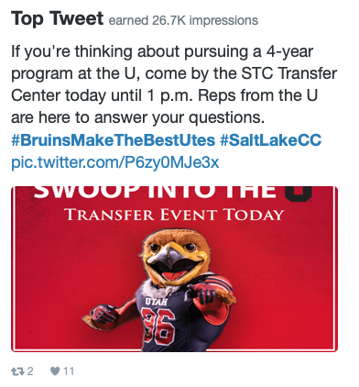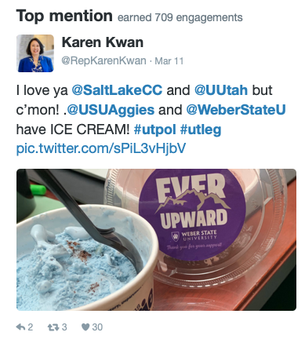

Top Media Tweet:
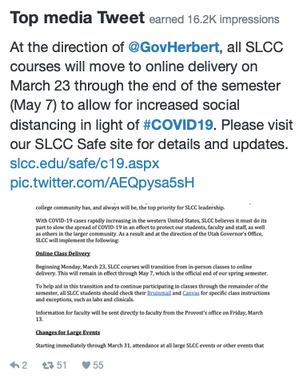

Facebook
Number of posts: 20
Post impressions: 135K
Page likes: 20,668 (+137)
Top post:
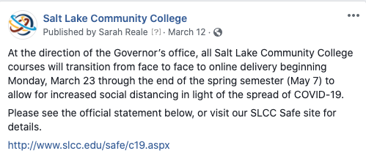

LinkedIn
Number of posts: 8
Page views: 988
Unique visitors: 563
Total followers: 60,693 (-37)
Likes: 178
Comments: 8
Shares: 9
Top Post:
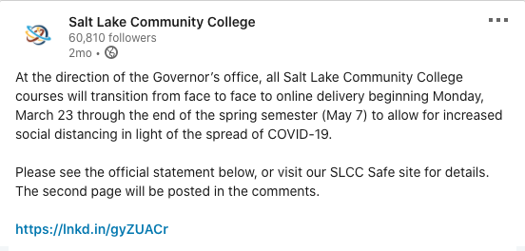

Instagram
Number of posts: 1
Number of stories: 28
Post likes: 56
Total followers: 3392 (+156)
Top post:
