May 2020

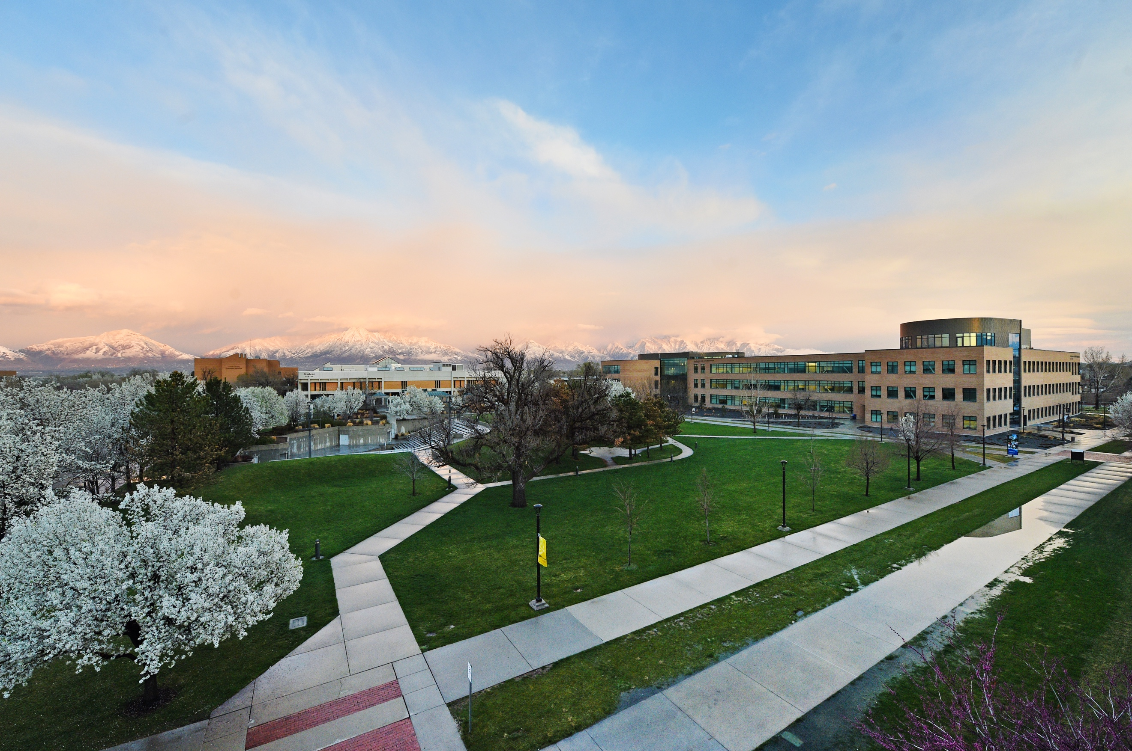

media Report
News Coverage

Summary
395 stories in national and local media. An estimated 4,240,350 people had subscriber access (reach) to these articles with an estimated earned media value of $345,175.68.

Media Advisory

May 4, 2020

To support the community during the ongoing COVID-19 pandemic, Salt Lake Community College is proud to offer a series of free summer workshops. (Press Calls, Media Advisory)

Top Stories

May 1, 2020

SLCC Announces Fundraiser for Students During #GivingTuesdayNow FINANCE.YAHOO.COM
SLCC's part in global day of giving targets $10,000 for students. Salt Lake Community College will participate in #GivingTuesdayNow, a special global day of giving during which the college aims to raise $10,000 on May 5 for its students who have been impacted by COVID-19.
May 1, 2020

SLCC announces fundraiser for students during #GivingTuesdayNow UTAHPOLICY.COM
Salt Lake Community College will participate in #GivingTuesdayNow, a special global day of giving during which the college aims to raise $10,000 on May 5 for its students who have been impacted by COVID-19.

May 4, 2020

Got time to learn something new? Check out SLCC's Free Virtual Workshops FINANCE.YAHOO.com
To support the community during the ongoing COVID-19 pandemic, Salt Lake Community College is proud to offer a series of free summer workshops designed to help Utahns get through what's anticipated to be a long season of social distancing.

May 4, 2020

SLCC offers 30 free summer workshops including how to start your own business KUTV.com
Salt Lake Community College is offering free summer workshops and registration for those courses begins Monday.
May 4, 2020

Sleep health during Covid-19 ABC4.COM

Terri Mehlhoff from Salt Lake Community College joined us today to discuss sleep health during this pandemic.

May 5 , 2020

SLCC invited to participate in Second Chance Pell Experiment for incarcerated students KUTV.COM

U.S. Secretary of Education Betsy DeVos announced Tuesday the U.S. Department of Education is inviting 67 schools to participate in its Second Chance Pell experiment, including Salt Lake Community College.

May 8, 2020

The Salt Lake Tribune’s Quarantine Film Festival: 29 films about isolation, hand-washing and having a laugh STRIB.com
What do filmmakers, in Utah and around the world, need to say about life during the coronavirus pandemic? Some want to talk about themselves, or to educate others. But a good number of submissions to The Salt Lake Tribune’s first (and, heaven help us, last) Quarantine Film Festival had the goal of making people laugh, or at least smile.

May 12, 2020

Guest opinion: A light at the end of the tunnel, SLCC prepares Utah’s workforce for economic recovery DESERET.COM

In these challenging times, higher education can be the light at the end of a dark tunnel — a light leading to opportunity, a better future and improved lives.

May 13, 2020

Utah colleges and universities join effort to sew 5 million medical-grade masks

KSL.COM

Utah’s public, private and nonprofit universities and colleges have launched a “Sew Your True Colors” campaign, asking their campus communities to sew medical-grade masks using thread in the color of their respective institutions.

May 13, 2020

How local businesses can adapt to a post-COVID pandemic environment DESERET.COM
The coronavirus pandemic has forced businesses and the individuals who provide the labor force to rethink how to operate in the workplace. With the transmission of a potentially deadly virus on the top of everyone’s mind, the status quo will no longer suffice, a Utah professor notes.

May 15, 2020

A Good Night's Sleep Can Impact Emotional Well Being DAVISCLIPPER.COM
In this crazy time of wearing masks and social distancing, many people may find themselves suffering from depression and anxiety. Getting a good night's rest might just help ease those problems.

May 26, 2020

Alan Hall: Utah higher education can recover to a better place DAVISCLIPPER.COM
Odds were against graduation for this year’s commencement speaker at Weber State University. Born into a home of addiction and abuse and raised in the foster care system, Clarissa McEuen was a young single mother five years ago.

Media Coverage Analytics
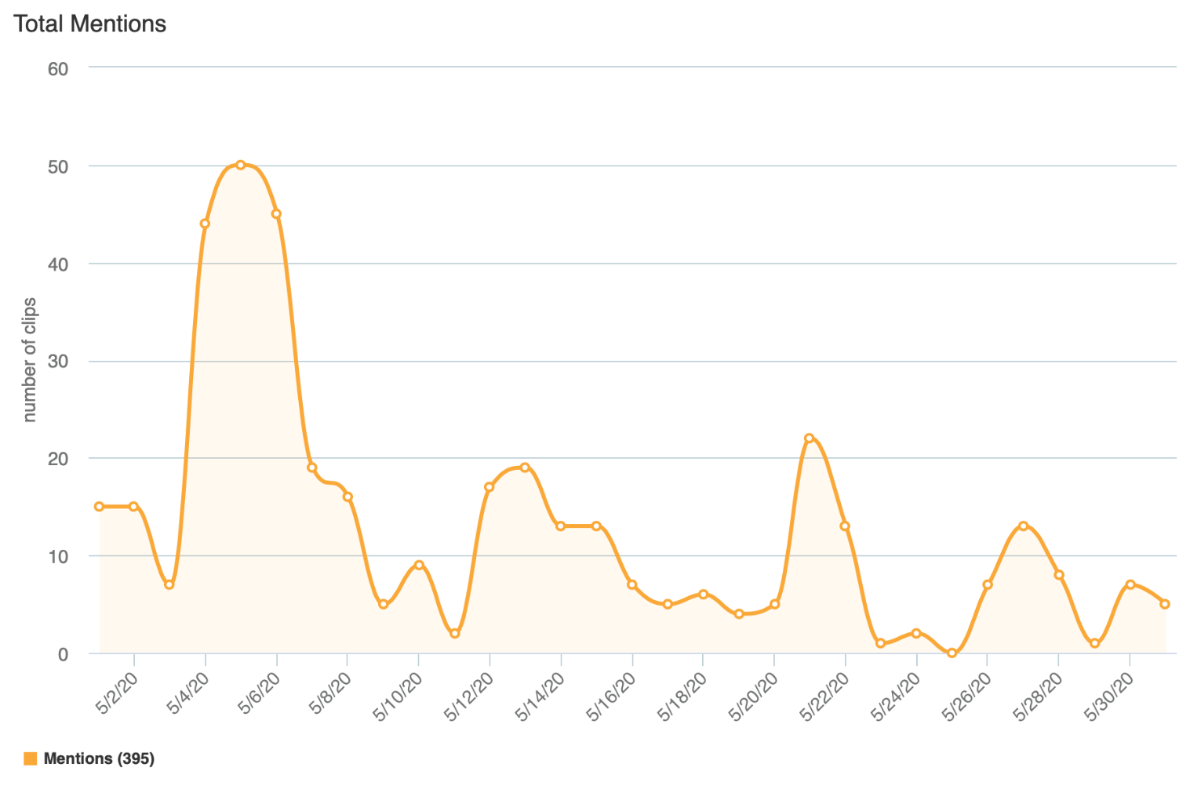

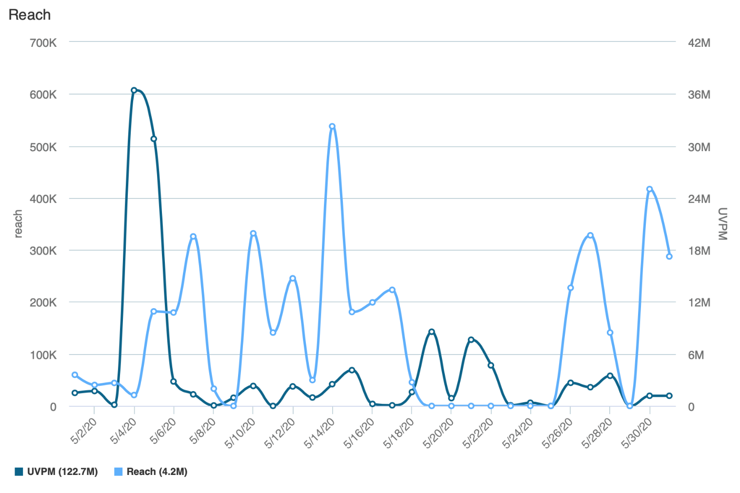
Reach is the Total Number of Unique Viewers/Readers, UVPM is the Total Number of Viewers Across All Social Platforms

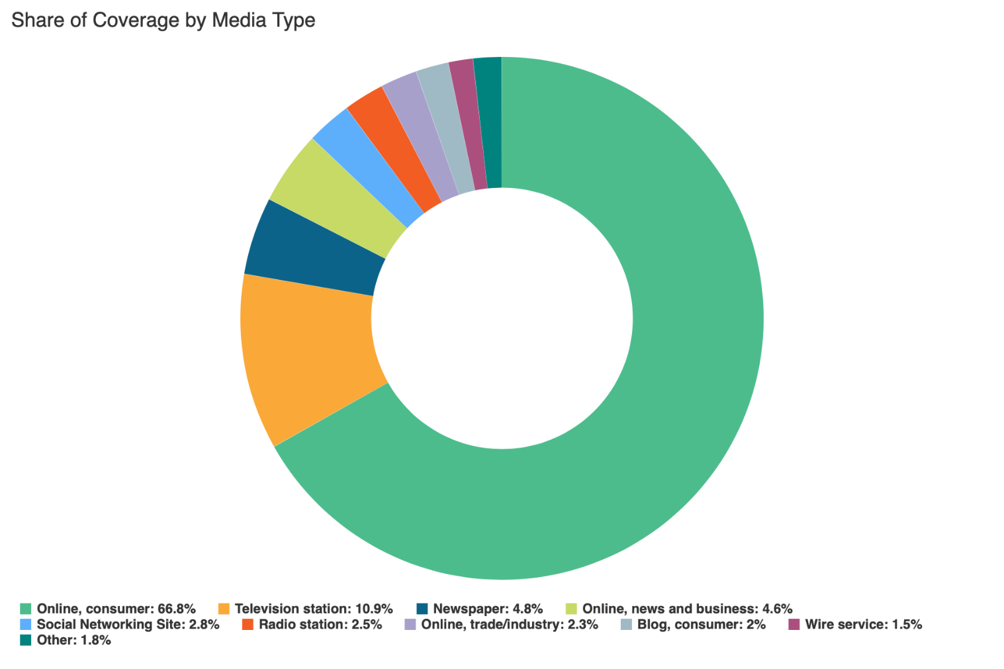

Social Media
SLCC Blog
A total of 24 blog posts were created and placed on the SLCC News and Events Page.
5.4 College Offering Free Online Summer Workshops for Community
Promoted on Twitter, Facebook, LinkedIn, SLCC Today

5.4 Betsy Specketer Bruin Achievement Award Announced
Promoted on Twitter, SLCC Today

5.4 SLCC President Outlines College Plans for Near Future
Promoted on Twitter, LinkedIn, SLCC Today

5.4 Available Positions on the SLCCSA Executive Council
Promoted on SLCC Today

5.4 Professional Development Opportunties for the Week of May 4–8
Promoted on SLCC Today

5.4 Innovations in Teaching: Creating A Virtual Choir
Promoted on Twitter, Facebook, LinkedIn, SLCC Today
5.6 Recreation Center Reopens for Appointments
Promoted on Twitter, Facebook, SLCC Today
5.8 Dual-Language Math, Biology Courses Offered
Promoted on SLCC Today

5.11 DECA President Finds Meaning in Clubs, Virtual Commencement
Promoted on Twitter, SLCC Today

5.11 Faculty Development Opportunities for the Week of May 11–15
Promoted on SLCC Today

5.11 SLCC Announces Soft Reopening of Some Services
Promoted on SLCC Today

5.11 College Employees Encouraged to Submit Videos for Virtual Commencement Ceremony
Promoted on Twitter, SLCC Today

5.11 Professional Development Training Opportunities for the Week of May 11–15
Promoted on SLCC Today

5.13 Guidance for Employees Returning to Campus
Promoted on SLCC Today

5.14 Deans Encourage Grads, Look Forward to Online Commencement
Promoted on Twitter, LinkedIn, SLCC Today

5.18 Upcoming GSSRC Events
Promoted on Twitter, SLCC Today

5.18 Soft Reopening Means Masks, Signs of the Times
Promoted on Twitter

5.18 Professional Development Opportunities for the Week of May 18–22
Promoted on SLCC Today

5.19 Two Mask-making Efforts at SLCC with One Community-minded Goal – the Greater Good
Promoted on Twitter, Facebook, LinkedIn, SLCC Today

5.20 College Community, 2020 Commencement Important to New SLCCSA President
Promoted on Twitter, Facebook, LinkedIn, SLCC Today

5.26 Professional and Faculty Development Opportunities for the Week of May 26-29
Promoted on SLCC Today

5.26 Reopening SLCC
Promoted on Twitter, Facebook, LinkedIn, SLCC Today

5.27 Commencement 2020: SLCCSA President Reflects, Looks Forward
Promoted on Twitter, Facebook, LinkedIn, SLCC Today

5.27 Rec Centers Open to Students
Promoted on Twitter, Facebook, LinkedIn, SLCC Today

Twitter
Number of tweets: 51
Tweet impressions: 99.4K
Number of mentions: 100
Follower Count: 4353 (+0)
Top Tweet: Top Mention:
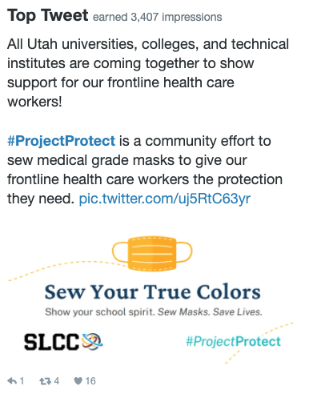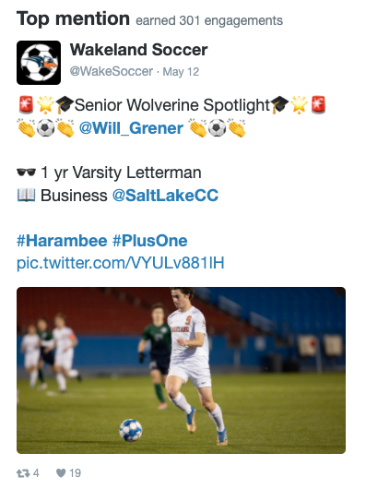

Top Media Tweet:
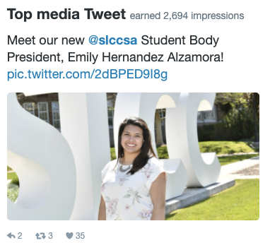

Facebook
Number of posts: 24
Post impressions: 103.5K
Page likes: 20,821 (+87)
Top post:
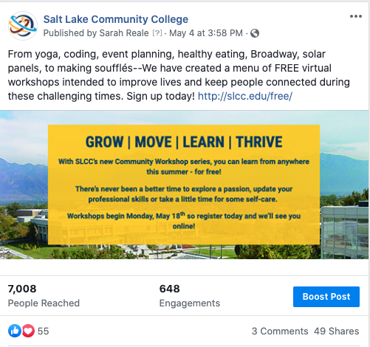

LinkedIn
Number of posts: 9
Page views: 1059
Unique visitors: 629
Total followers: 60,932 (-18)
Likes: 170
Comments: 0
Shares: 25
Top Post:
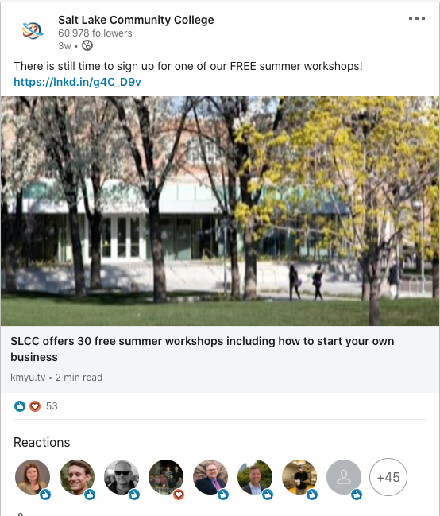

Instagram
Number of posts: 2
Number of stories: 24
Post likes: 289
Total followers: 3569 (+104)
Top post:
