EMERGENCY PREPAREDNESS
Every day millions of people wake up, go to work, take kids to school, farm their lands or go to ball games. But every so often the unexpected happens: an earthquake, a fire, a chemical spill or some other emergency. Routines change drastically and people are suddenly aware of how fragile their lives can be. Disasters disrupt hundreds of thousands of lives every year and each disaster has lasting effects - people are seriously injured, sometimes killed and property damage runs into the billions of dollars.
You should know how to respond to severe weather or any disaster that could occur in your area: hurricanes, earthquakes, lightning, extreme cold weather and floods. You should also be prepared to be self - sufficient for at least three days. This may mean providing your own shelter, first aid, food, water and sanitation.
There are six (6) basic items to include in any size emergency kit:
- Food
- Tools / Emergency Supplies
- First Aid Supplies
- Clothing and Bedding
- Water
- Special Needs Items
You should have emergency kit(s) for:
- Home
- Vehicle
- Place of Business
- Child Bedside Backpack
- Baby Diaper Bag Refilled Always
- Students (Book Backpack)
- House Pets
Emergency Container Tip:
Create emergency kit(s) and store in any type of containers. Containers with wheels are great for larger kits; garbage cans, foot - lockers, chest, duffle bags, tote bags, ice chest, various sizes of suitcases, various sizes of plastic boxes, even a pillow case, blankets or sleeping bags will work to roll - up emergency supplies in!
If you would like more information about natural disasters, preparedness, training, maps, hazardous materials, or if you are interested in having an emergency preparedness presentation for a group (businesses, church gatherings, family reunions, etc.) with a demonstration of an earthquake and sound effect, please contact us at (801) 538 - 3400.

Basic First Aid Kit
- First Aid Manual or Guide
- Band - Aids (various sizes)
- Gauze (various sizes)
- Triangular bandages
- Elastic bandages with pins
- Cotton balls or cotton square pads
- Disposable diapers (dressing / splint / padding)
- Sanitary napkins (pressure dressing)
- Non - adherent sterile pads (various sizes)
- First aid tape or micropore adhesive, or paper tape
- Anti - bacterial ointment (Neosporin, bacitracin, etc.)
- Burn cream
- Eye wash
- Iodine pads or plastic bottle
- Petroleum jelly
- Rubbing alcohol swabs or plastic bottle
- Hand soaps
- Salt
- Hand wipes (antiseptic)
- Rubber disposable gloves
- Small splints, popsicle sticks
- Non - aspirins, pain relievers, ibuprofen, essential medications
- Laxatives or diarrhea medicine
- Syrup of Ipecac
- Baking soda (1 / 2 tsp. Soda + 1 tsp. Salt + 1 qt. water for shock)
- Chemical ice pack, hand warmer packets
- Safety pins (various sizes), needles and heavy thread
- Scissors, tweezers, pocket knife, razor blade, etc.
- Thermometer
- Matches (water proof / wind proof)
- Water pouches (option)

Vehicle
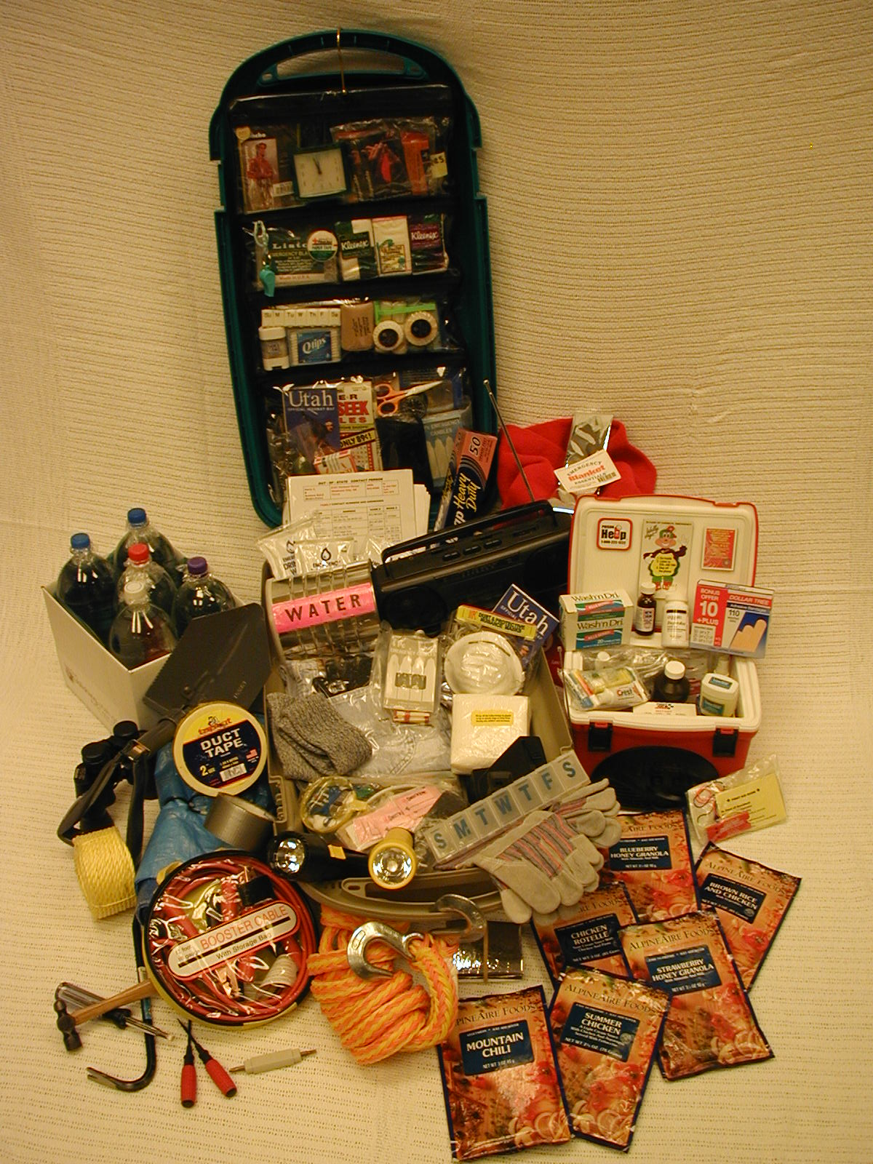
- Always maintain at least 1 / 2 tank of gas
- Tools needed to change flat tire
- Jumper cable
- Road emergency flares
- Tow rope (option)
- Fire extinguisher (Standard Class ABC)
- Siphoning hose (option)
- Bag of sand or rock salt (option)
- Collapsible shovel
- First Aid Kit and First Aid Guide Information (basic)
  - Band aids and gauze, non - adherent sterile pads (various sizes)
  - First aid tape
  - Anti - bacterial ointment (Neosporin, bacitracin, etc.)
  - Burn cream
  - Scissors, tweezers, pocket knife, razor blade, etc.
  - Large cloth square for a sling or tourniquet
  - Non - aspirins, pain relievers, ibuprofen
  - Chemical ice pack, hand warmer packets
  - Safety pins (various sizes), needles and heavy thread
  - Matches (water proof)
  - Eye wash
  - Hand wipes (antiseptic), cotton balls, cotton pads
  - Alcohol swabs, iodine (bottle or pads)
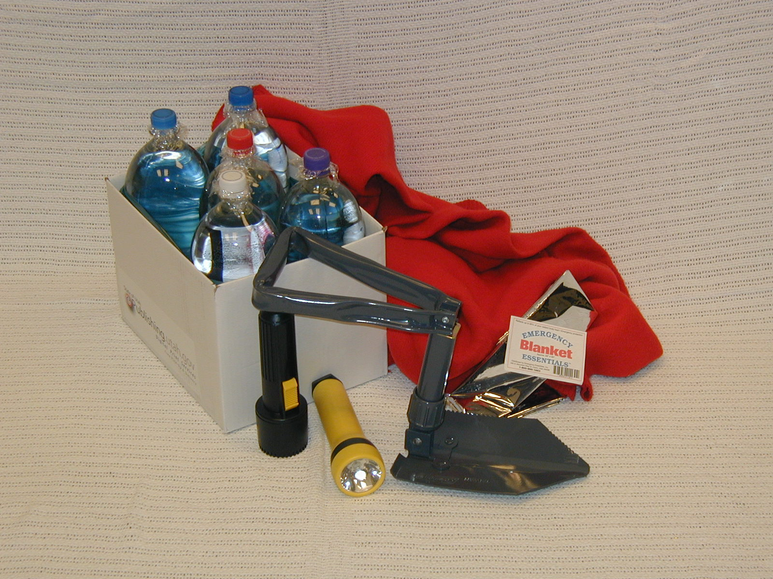
- Flashlight (extra batteries). Suggested 2 with 1 as back - up
- Coat(s) or jacket(s)
- Emergency (Mylar) blankets are great to keep warm
- Water: clear liter bottles (filled 3 / 4 full to allow freeze expansion). Rotate water every six (6) months. Place in a box to keep from flopping around during vehicle movement
- Rubber disposable gloves
- Whistle with lanyard to hang around neck
- Additional car kit supplies:
  - Sanitation (toilet tissues)
  - Freeze - dried or nonperishable canned foods and a can opener! (option)
  - Writing pad and pencils, maps
  - Ice scraper for winter season

Office
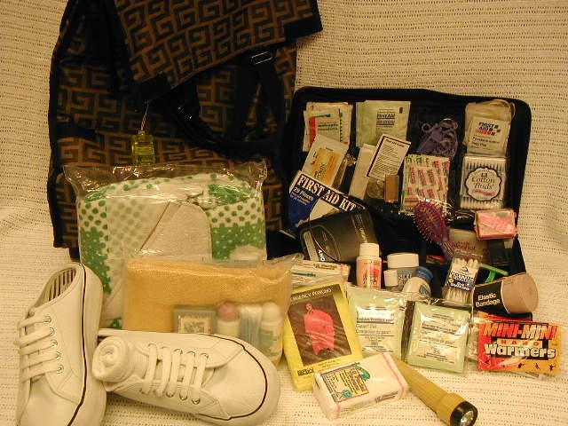
Keep a backpack, tote bag, small box or suitcase on wheels underneath your desk for any emergency use.
- First Aid Kit and First Aid Guide Information (basic)
  - Band aids and gauze, non - adherent sterile pads (various sizes)
  - First aid tape
  - Anti - bacterial ointment (Neosporin, bacitracin, etc.)
  - Burn cream
  - Scissors, tweezers, pocket knife, razor blade, etc.
  - Large cloth square for a sling or tourniquet
  - Non - aspirins, pain relievers, ibuprofen
  - Chemical ice pack, hand warmer packets
  - Safety pins (various sizes), needles and heavy thread
  - Matches (water proof)
  - Eye wash
  - Hand wipes (antiseptic), cotton balls, cotton pads
  - Alcohol swabs, iodine (bottle or pads)
  - Rubber disposable gloves
- Flashlight (extra batteries). Suggested 2 with 1 as back - up
- Coat or jacket
- Change of clothes, socks, shoes (women flat shoes), undergarments, etc.
- Blanket, flat sheet, throw pillow or a single sleeping bag
- Emergency (Mylar) blankets are great to keep warm
- Trial size hand and body lotions, soaps, shampoo / conditioner, etc.
- Trial size toothbrush, toothpaste, mouthwash, toothpicks, etc.
- Towel, wash cloth
- Freeze - dried or nonperishable canned foods and a can opener! (option)
- Sweet hard candy
- Water: clear liter bottles (rotate water every six (6) months) or water pouches
- Whistle with lanyard to hang around neck
- In case of an emergency, have a list of names, home and business telephone numbers

Creat your office kit with items you require

Due to a major disaster, you may be stranded at your place of business for several days

Child Bedside Backpack
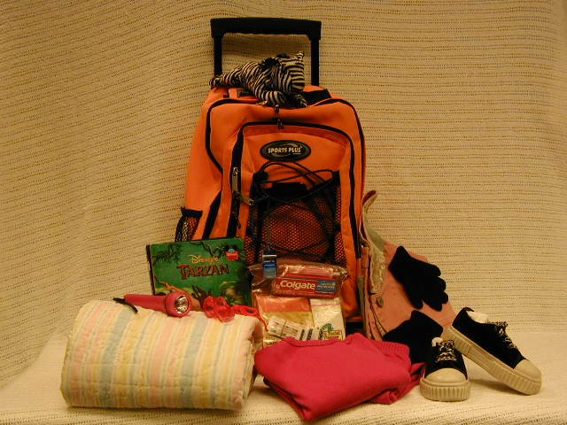
Place back pack underneath head of bed with handle facing out for quick grab. Also, keep extra pair of hard sole shoes near bed for quick evacuation for children and adults.
Contents:
- 1 back pack (or a tote bag, duffle bag or a small suit case on wheels)
- 1 warm jacket or sweater (gloves to keep hands warm)
- 1 sweat shirt and 1 sweat pants
- 2 pair of socks
- change of under garments
- small blanket or emergency blanket (Mylar blanket, space blanket)
- coloring book(s) with colored crayons
- writing pads with pencils (colored pencils)
- reading books
- small stuffed animal for security as a stress relief
- children should have their own flash light with extra batteries
Zip Lock Bag Items for Back Pack
- 1 emergency poncho (one size fits all & children sizes)
- 1 hand / body warmer (2 per packet)
- trial size tooth paste and tooth brush
- trial size moisture lotion
- trial size shampoo / conditioner
- 4 moist hand towelettes
- 4 sterile alcohol swabs to clean wound or cuts
- variety size band aids
- 2 pocket size facial tissues
- trial size bar soap or trial size hand sanitizer (kills germs without water)
- nail file or nail clippters (optional)
- Q - tips, cotton swabs or cotton pads to clean wounds or cuts
- various size safety pins (in case you pop a button or a broken zipper!)
- 1 blow whistle with lanyard to hang on back pack (whistles can be heard over voice)

Baby Diaper Bag
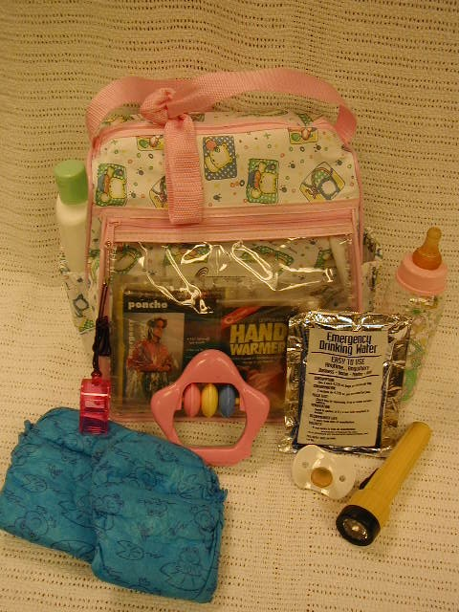

KEEP BABY DIAPER BAG REFILLED ALWAYS & PLACE NEXT TO CRIB
- Refill baby diaper bag with baby needs.
- Have a few emergency items in the baby diaper bag, such as; an emergency Mylar blanket, rain poncho, mini flash light, blow whistle, emergency water pouches (place 2 pouches in separate zip lock bags to protect leakage).
- Keep extra baby pacifier (binky) in bag, no time to search for one during a disaster.
- If baby is still on formula, keep extra in diaper bag along with water pouches.
Emergency items can be purchased at your local emergency essential stores, and various stores in the camping section.
- Emergency Mylar Blanket $1.99 or less
- Rain Ponchos $.99 or less
- Plastic Blow Whistle (won't rust)
- Mini Flash Light from $2.99 and up
- Have extra batteries available
- Emergency Water Pouches $.25 each

Students (Book Backpack)
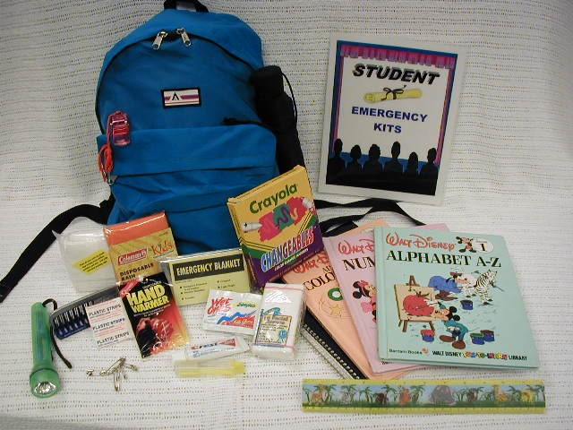
Contents:
- 1 sandwich size zip lock bag (place all items listed below into zip lock bag)
- 1 emergency blanket (Mylar; looks like tin foil!)
- 1 emergency poncho (one size fits all & children sizes)
- 1 hand / body warmer (2 per packet)
- trial size tooth paste and tooth brush (for dentist appointment)
- trial size moisture lotion
- 4 moist hand towelettes
- 4 sterile alcohol swabs to clean wound or cuts
- variety size band aids
- various size safety pins (in case you pop a button or a broken zipper!)
- 1 blow whistle with lanyard to hang on back pack (whistles can be heard over voice)

House Pets
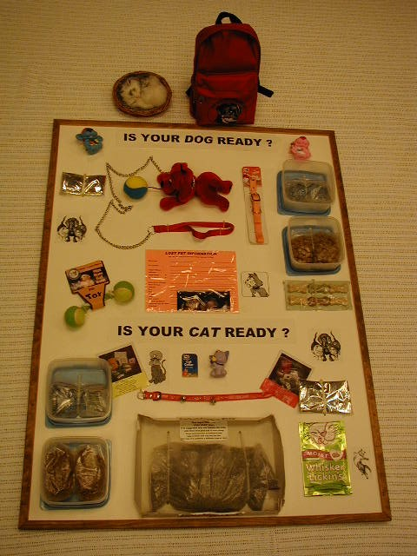

Our pets enrich our lives in more ways than we can count.

In turn, they depend on us for their safety and well - being. Here's how you can be prepared to protect your pets when disaster strikes.
To prepare your pet for a natural disaster, keep the following things in a protected area in a portable container (trash can with lid, large plastic box with lid; etc.):
Is Your Dog Ready? | Is Your Cat Ready?
- 1 week supply of his / her regular dog food  - don't forget a can opener to open canned food  - 6 gallons of water  - plastic food & water dish (non - spill)  - 1 week supply of any medicines if needed  - extra collar and leash  - portable dog carrier  - towel or blanket for bedding in dog carrier  - favorite toy(s) to chew or play with  - copy of veterinary records with current photo of pet | - 1 week supply of his / her regular cat food  - don't forget a can opener to open canned food  - 2 gallons of water  - plastic food & water dish (non - spill)  - litter box & 20 lb. bag of litter  - extra collar, harness or leash  - portable cat carrier  - towel or blanket for bedding in cat carrier  - favorite toy(s) to chew or play with  - copy of veterinary records with current photo of pet
First Aid Kit for Your Dog | First Aid Kit for Your Cat
- gauze pads & bandages  - roll of cloth tape  - scissors  - thermometer (option)  - hydrogen peroxide  - antibiotic ointment  - tweezers  - first aid book for dog's care | - gauze pads & bandages  - roll of cloth tape  - scissors  - 1 week supply of any medicines if needed  - hydrogen peroxide  - antibiotic ointment  - tweezers  - first aid book for cat's care

Save your pet's life ~ make sure he / she wears a collar and identification tag at all times so you can find him / her if lost.

Transporting Your Pet In An Emergency

Plan and prepare ahead of time to make your evacuation with your pet quick and safe!
- make sure he / she is wearing a collar and identification tag
- keep pet(s) on leash or in a carrier at all times
- avoid feeding pets immediately before leaving (this could upset their stomach)
- make sure cleaning supplies are easily accessible (paper towels, disinfectant, plastic bags, scoop spoon; etc.)
- when you reach your destination, give your pet(s) a quiet, safe place to rest. Allow him / her to adapt to new surroundings, then offer food & water

For Support and training on 72 Hours kits contact:

Maralin Y. Hoff
Trainer
Department of Homeland Security
1110 State Office Building
Salt Lake City, UT 84114
801-538-3166
mhoff@utah.gov

