January 2020

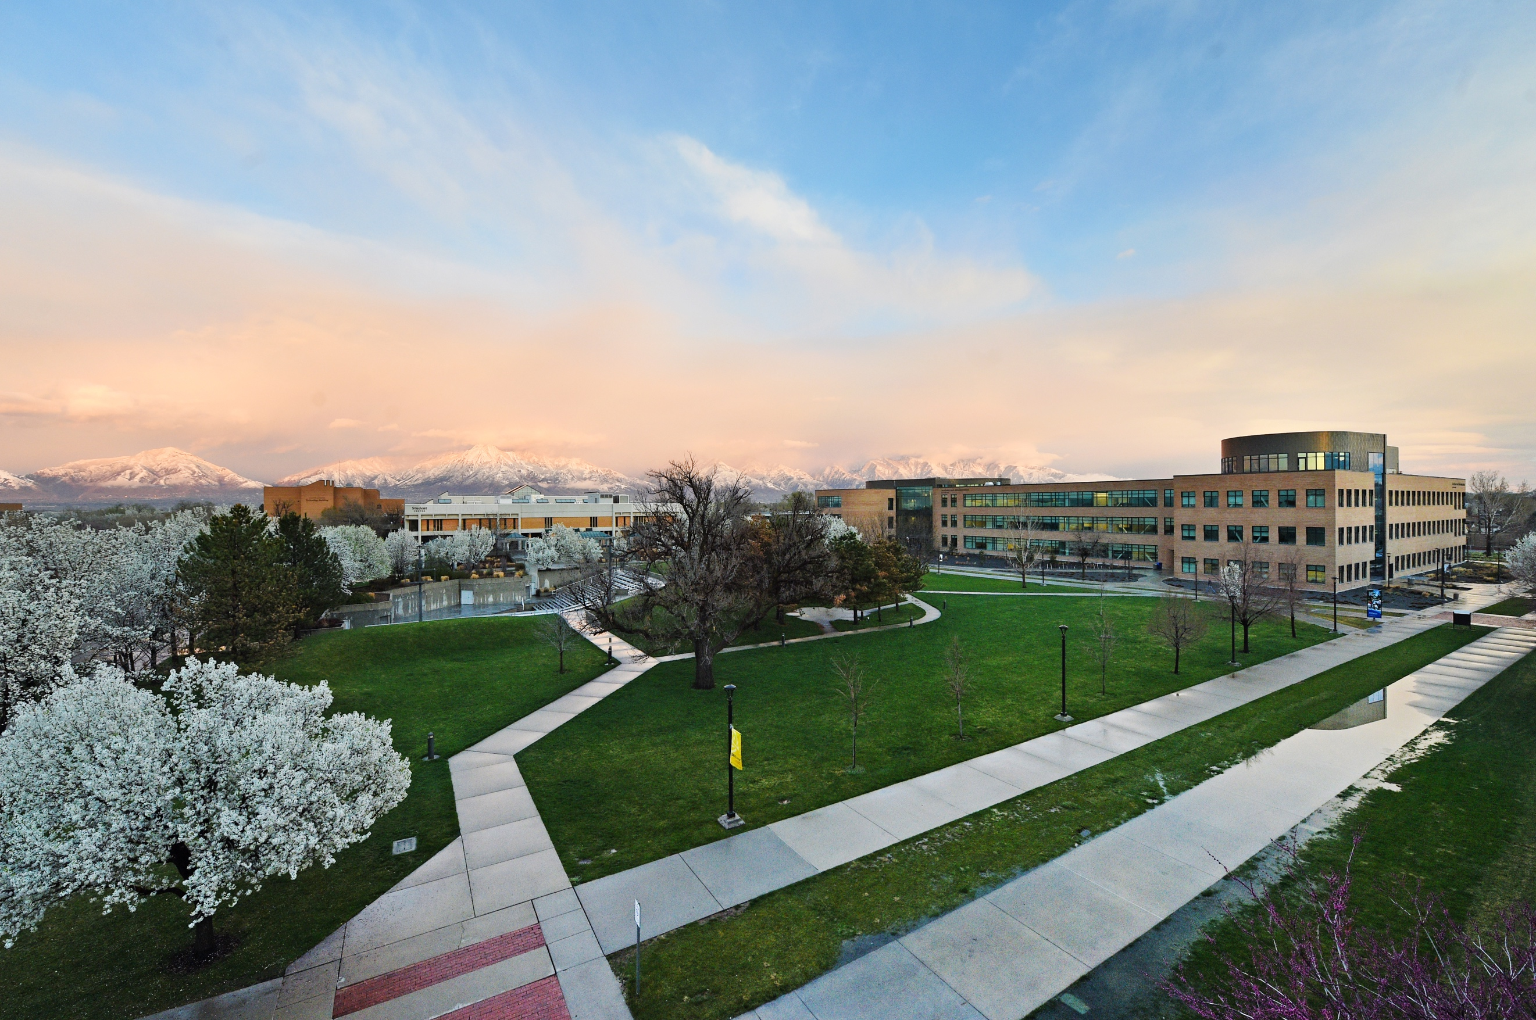

media Report
News Coverage

Summary
448 stories in national and local media. An estimated 857,419 people had subscriber access (reach) to these articles with an estimated earned media value of $331,950.43.

Press Releases

January 8, 2020
SLCC Promise tuition assistance program expanded to provide greater access, financial support for students

January 17, 2020
Exonerated Central Park Five’s Yusef Salaam and Raymond Santana are SLCC’s 2020 MLK Commemorative Keynote Speakers

January 20, 2020
SLCC Grand Theatre’s 2020 Sundance Lineup to feature Salt Lake Premiere of Taylor Swift Documentary

Top Stories

January 13, 2020

DEVELOPING TALENT THROUGH EDUCATION Utahbusiness.com

The Division of Workforce & Economic Development at Salt Lake Community College (SLCC) supports the economic development of Utah’s information technology industry through its training programs, serving both companies and individuals. Developing talent through education contributes to the growth of existing and start-up tech companies. SLCC also finds that IT skills are critical to growth in other industry sectors, such as manufacturing, transportation, healthcare, and energy-related fields.

January 17, 20

Sundance films with free parking? About screenings at SLCC’s Grand Theatre FOX13NOW.com

Sundance Film Festival hits Utah January 23, running through Feb. 2, 2020 and those who aren't prepared to brave the bustling Park City scene, Salt Lake Community College offers you screenings at The Grand Theatre at their South City Campus.

January 20, 2020

SLCC Grand Theatre's 2020 Sundance Lineup to feature Salt Lake Premiere of Taylor Swift Documentary YAHOO.COM

The 2020 Sundance Film Festival will screen 19 films at Salt Lake Community College's Grand Theatre, Jan. 24-Feb. 2, during the event's opening and closing weekends. This is the sixth year the Grand will host film enthusiasts from around the world during the annual festival.

January 21, 2020

How you can see some of the greatest movies at the Sundance Film Festival ABC4.COM

The Grand Theatre on Salt Lake Community College’s South City Campus will once again host filmmakers and international audiences during the annual Sundance Film Festival in January, when for 10 days people from around the world flock to Park City and Salt Lake City to see the best of independent filmmaking. It’s the sixth year in a row that SLCC and Sundance Institute have partnered to bring independent filmmaking to more theater goers as the festival grows in popularity.

January 21, 2020

Taylor Swift documentary premieres in Salt Lake City at The Grand Theatre for Sundance KUTV.COM

The 2020 Sundance Film Festival is screening 19 films at Salt Lake Community College's Grand Theatre beginning Friday through Feb. 2, which includes Taylor Swift's documentary.

January 24, 2020

Swiss Apprenticeships in Utah INSIDEHIGHERED.COM
New program uses the European model to give students training for advanced manufacturing through a hybrid model blending an apprenticeship with coursework at Salt Lake Community College. A Swiss company is bringing its apprenticeship model to Utah to build a skilled workforce for its new facility in this country.

January 30, 2020

Free tax help reaches more residents through community partnerships UTAHPULSE.COM
Westminster’s Tax Clinic has expanded the number of people served by also partnering with Salt Lake Community College. SLCC students enrolled in ACCT 2570 are also providing free tax services to qualified individuals. Students are IRS-certified volunteers through the Volunteer Income Tax Assistance (VITA) program. Westminster’s VITA tax clinic provides free tax help to low-to-moderate income families, persons with disabilities and limited English-speaking taxpayers who need assistance in preparing and electronically filing their own tax returns.

Media Coverage Analytics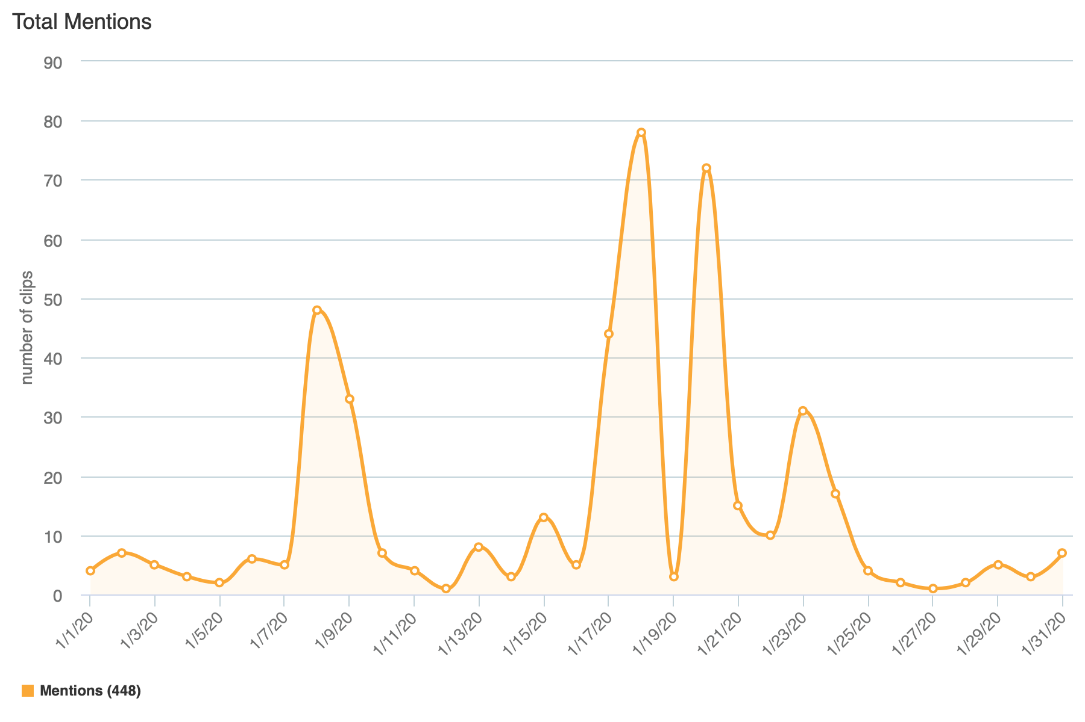

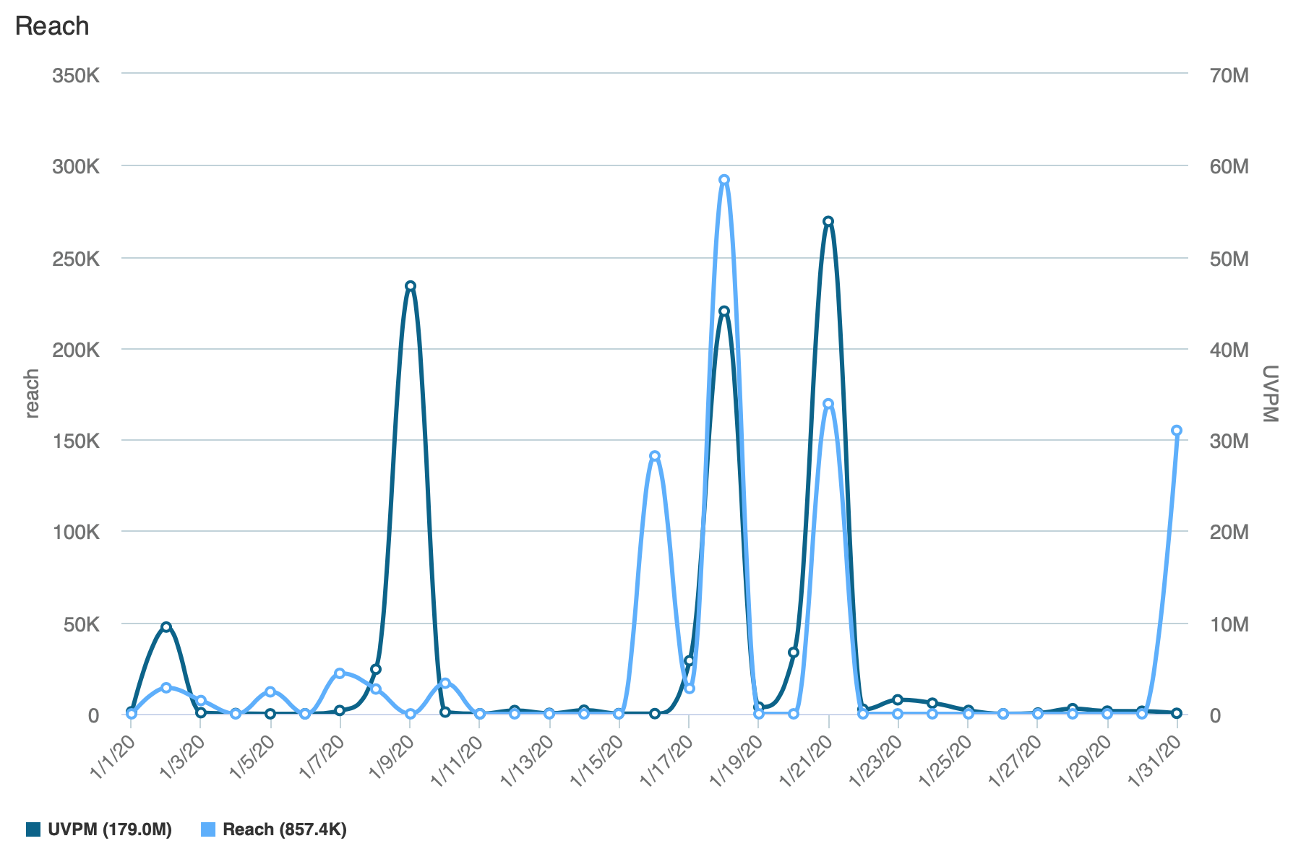
Reach is the Total Number of Unique Viewers/Readers, UVPM is the Total Number of Unique Viewers/Readers Across All Social Channels

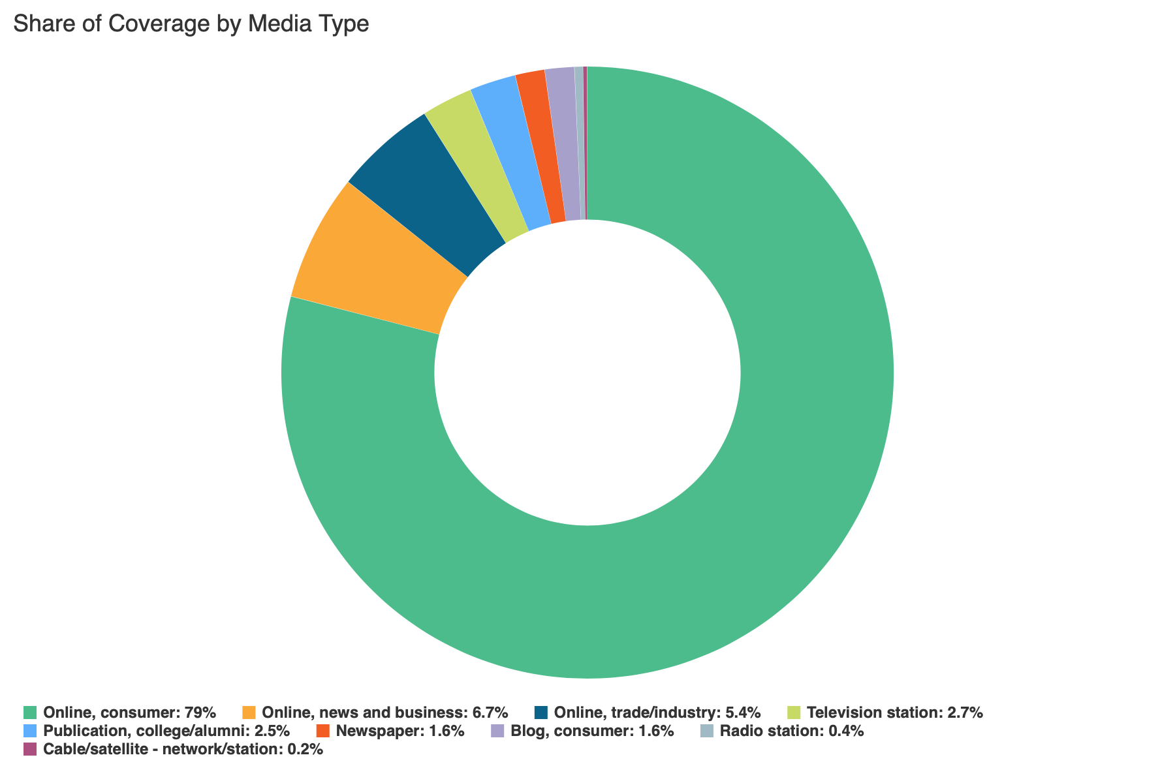

Social Media
SLCC Blog
A total of 10 blog posts were created and place on the SLCC News and Events Page.
1.8 MLK Keynote: Two from Central Park Five Speaking at Grand Theatre
Promoted on Twitter, Linkedin, Facebook

1.8 SLCC Strengthens Communities through Marriage Skills Workshop

1.8 SLCC Promise Tuition Program Expanded to Provide Greater Access and Financial Support to Students
Promoted on Twitter, Linkedin, SLCC Today

1.13 Study Abroad and Domestic Study 2020
Promoted on SLCC Today

1.13 Day One: Getting to Know Students at South City Campus
Promoted on Twitter

1.15 College’s Zac Curtis to Receive Outstanding Contribution Award from Utah Theatre Association
Promoted on Twitter, Linkedin, SLCC Today
1.17 Grand Theatre’s 2020 Sundance Lineup to Feature Salt Lake Premiere of Taylor Smith Documentary
Promoted on Twitter, Linkedin, SLCC Today

1.21 SLCC Helping Young Students Envision College as Part of their Future
Promoted on Linkedin, SLCC Today

1.21 Seeking the Best Talent
Promoted on Linkedin, SLCC Today

1.21 Improving Online Education to Increase Student Completion
Promoted on Linkedin, SLCC Today

Twitter
Number of tweets: 16
Tweet impressions: 151K
Number of mentions: 86
Follower Count: 4131 (+16)
Top Tweet: Top Mention:
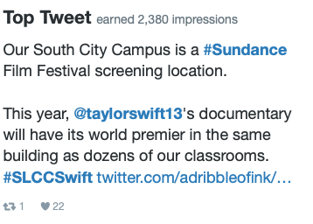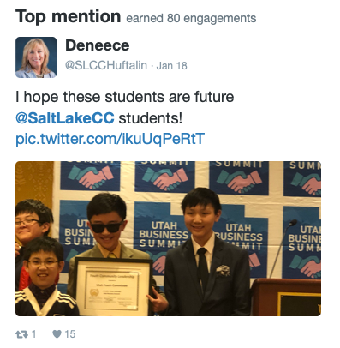

Top Media Tweet:
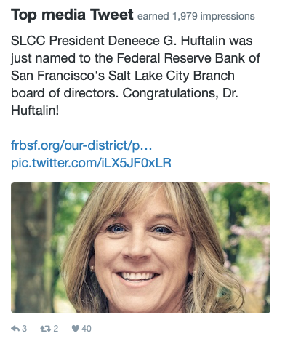
Facebook
Number of posts: 11
Post impressions: 143,253
Page likes: 20,357 (+61)
Top post:
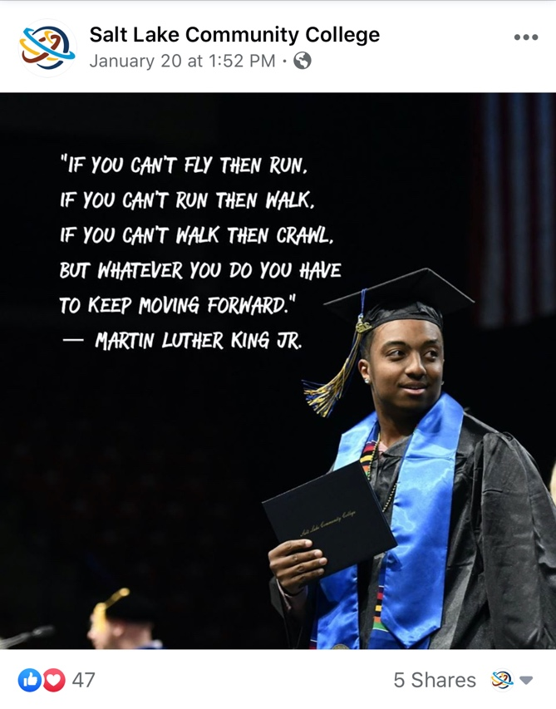

LinkedIn
Number of posts: 3
Page views: 1,123
Unique visitors: 568
Total followers: 60,773 (-69)
Likes: 71
Comments: 4
Shares: 1
Top Post:
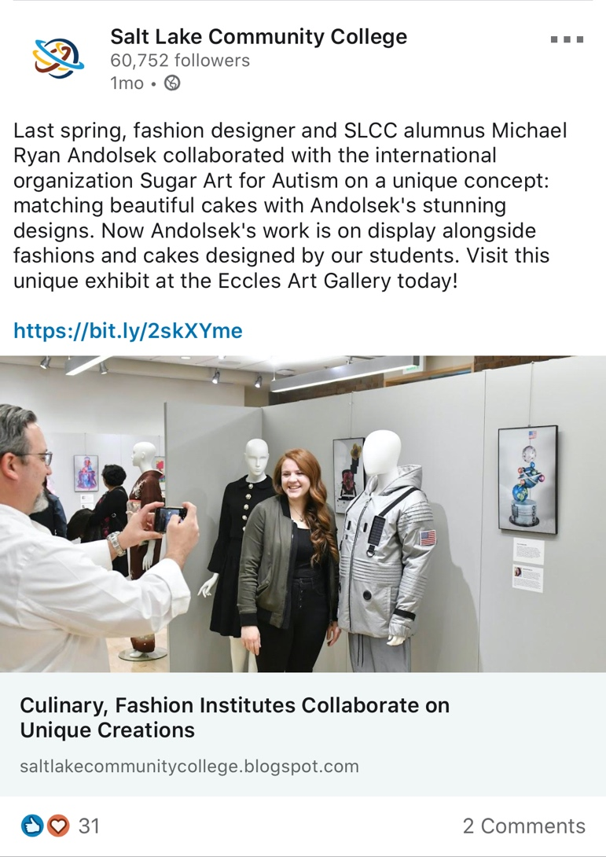

Instagram
Number of posts: 7
Number of stories: 26
Post likes: 667
Total followers: 3094 (+77)
Top post:
