December 2019

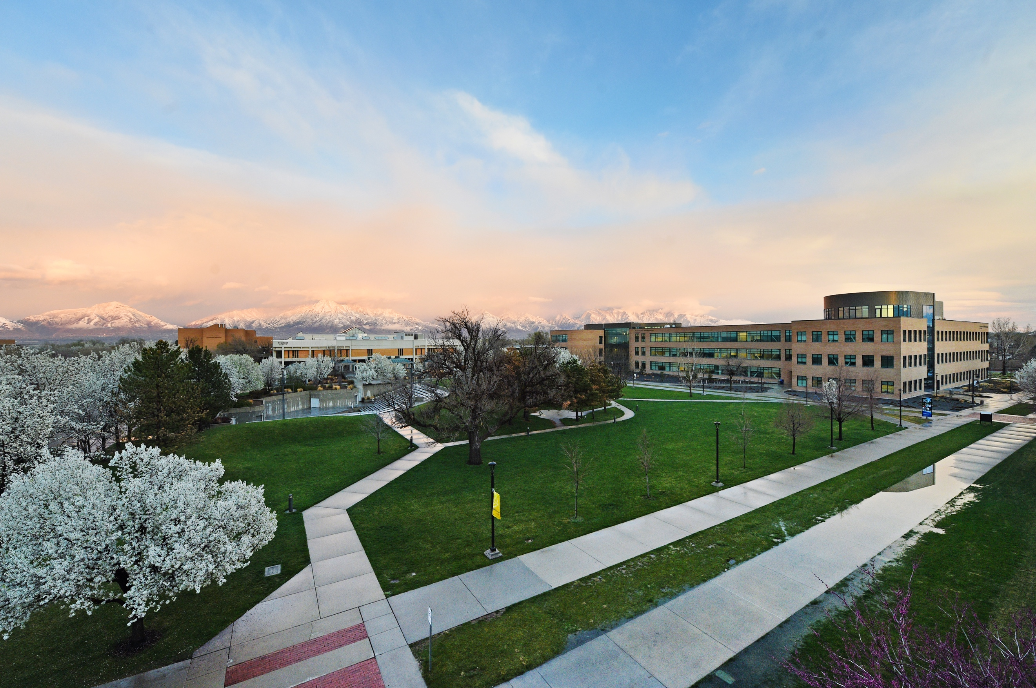

media Report
News Coverage

Summary
275 stories in national and local media. An estimated 692,737 people had subscriber access (reach) to these articles with an estimated earned media value of $466,693.49.

Press Releases

December 6, 2019
SLCC Emergency Medical Technician Students Receive $11,000 in Scholarships from AT&T

December 12, 2019
Good Taste (Local Press Calls and Media Invitations)

Top Stories

December 2, 2019

New Programs: Cybersecurity, Engineering, Digital Marketing INSIDEHIGHERED.COM
- Bob Jones University is starting an undergraduate major in cybersecurity.
- New York University and the Indian Institute of Technology, Kanpur, are starting dual doctoral degrees in computer and electrical engineering.
- Salt Lake Community College, in collaboration with Facebook, is starting a certificate in digital marketing.

December 4, 2019

Pan Fried Pork Cutlets With Red Cabbage Slaw KSL.com

Every party needs a menu, and this one will have you practicing all the culinary skills! Serve up a tasty pork cutlet to your guests, and they’ll be racing for seconds. Jeffrey Coker, with the Culinary Arts Program at Salt Lake Community College, and one of his students, Jake Smith, share how to make this holiday dish.

December 6, 2019

SLCC Emergency Medical Technician Students Receive $11,000 in Scholarships from AT&T YAHOO.COM

In a ceremony where words like "commitment," "bravery" and "gratitude" were used frequently, six students in Salt Lake Community College's (SLCC) Emergency Medical Technician (EMT) Program—Maria Mazzel Delgado, Jake Fisher, Justine Hanscom, Hevelyn Cidade Klegues, Mark Rodgersand Chelise Schaefer—were awarded the AT&T Public Safety Hero Scholarship to support their first responder training. Four scholarship recipients are graduating from SLCC's EMT program this month and two are prepared to begin the 13-week program in January.
December 12, 2019

SLCC Men’s Basketball Team Visits Local Elementary School KSLSPORTS.ORG

The Salt Lake Community College men’s basketball team visited Taylorsville Elementary to spend time visiting and participating in activities with the students. The Bruins basketball team visited the local elementary school on Wednesday, December 11.

December 11, 2019

Utah women work part time at highest rate in U.S. SLTRB.COM

Nile Checketts had reached “the final straw.” More than half of her salary was going to the nanny, and her job wasn’t flexible enough for her to be home with her two kids on days the nanny didn’t show up. So, Checketts quit her daytime office position and got a part-time gig at night at an ice cream shop. “I just felt such a sense of relief not trying to work on child care anymore,” she said.

December 13, 2019

How to Save Money on a Higher Education KSL.COM
As an open-access institution, Salt Lake Community College is committed to the idea that higher education should be available to anyone who wishes to obtain it, and we are dedicated to developing ways to make college affordable. Keeping costs down is essential for student success and helps minimize their student loan debt, which can often cripple them financially.

December 15, 2019

Distinguished Geospatial Speaker Series: Implementing Open Geography Education DIRECTIONSMAG.COM
Open Education Global (OEG), an international network for open education, recently announced Adam Dastrup, Professor of Geosciences at Salt Lake Community College (SLCC), won OEG’s prestigious Open Geography award. In 2014, Adam Dastrup started the Open Geography Education initiative as a way to provide educators with OER textbooks to students. The philosophy of the initiative is to provide open resources, products and services to anybody interested in learning about the earth, its places and the relationships between people and their environments.

December 16, 2019

Ed Dept ends competency-based education experiments EDUCATIONDIVE.COM
The U.S. Department of Education is ending experiments that allowed participating colleges with competency-based education (CBE) programs to receive federal aid, according to an agency letter obtained by Education Dive. Launched in 2014, the experiments waived federal aid rules for some colleges with CBE programs, which allow students to complete coursework mostly at their own pace instead of on a fixed schedule. The aim was to collect data to inform policy decisions on CBE. Inside Higher Ed first reported the Ed Department was halting the experiments.
December 20, 2019

How Salt Lake Community College keeps college affordable ABC4.COM
Keeping college affordable is a big deal these days. Keeping costs down is the number one thing Salt Lake City Community College does to make college affordable. Affordability is essential for student success and helps minimize student loan debt. In fact, students wanting to earn four-year degrees can save about $10,000 by first earning their associate’s degree at SLCC and then transferring to one of the state’s universities. SLCC tuition assistance program started in 2016 and has helped full-time students cover the cost of tuition when federal grants fall short. When a student is eligible for only some federal financial aid, SLCC promises to pay the rest. To date, their Promise program has awarded $2.75 million to more than 2,000 full-time students.

Media Coverage Analytics
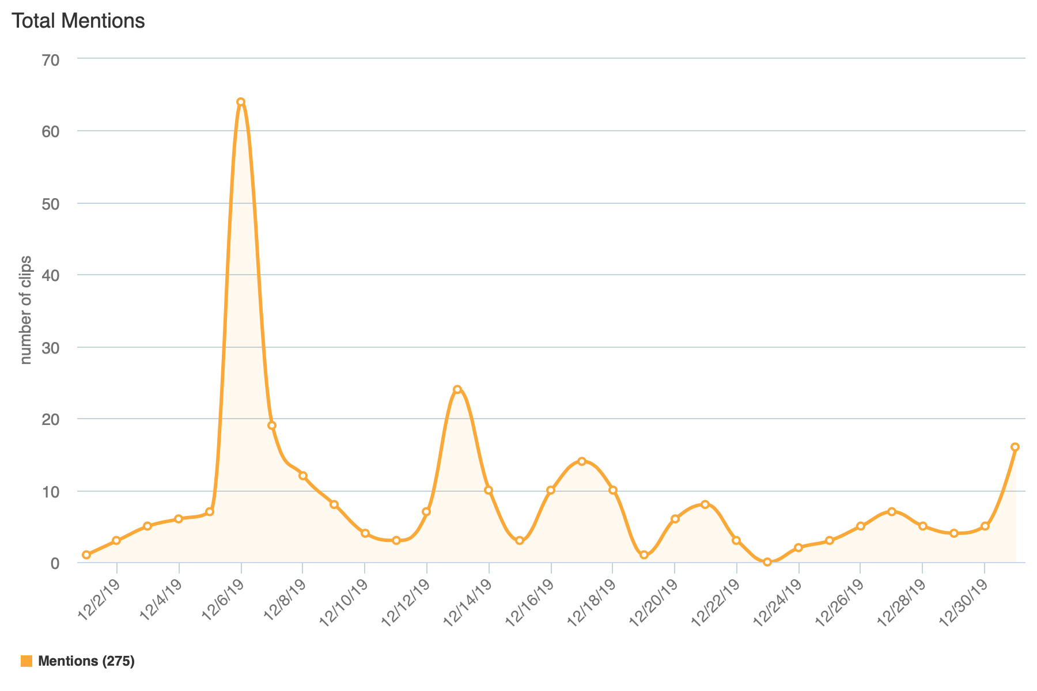

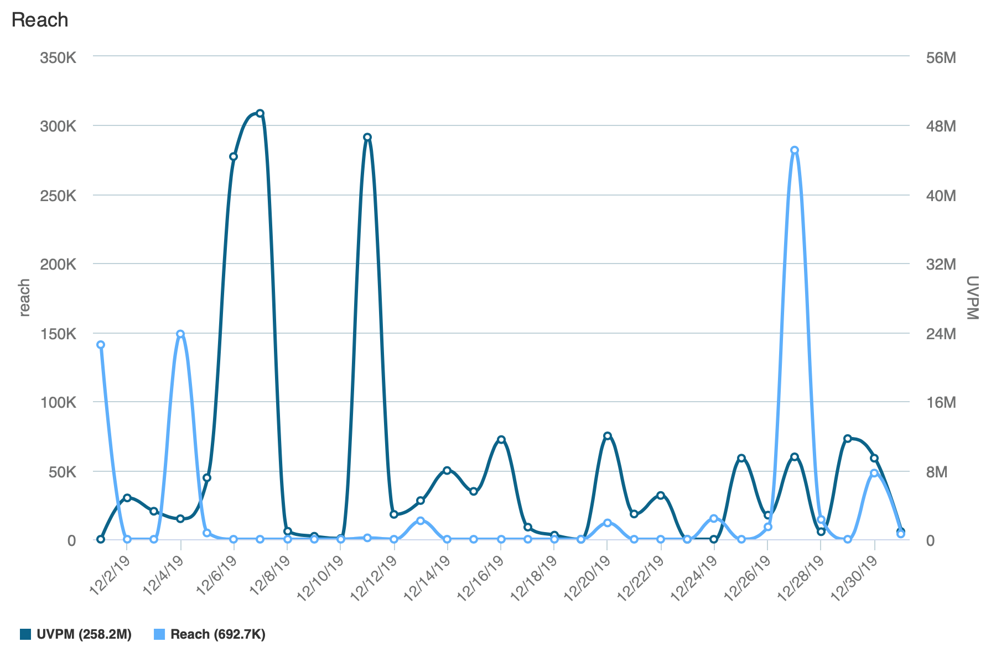
Reach is the Total Number of Unique Viewers/Readers, UVPM is the Total Number of Unique Viewers/Readers Across All Social Platforms.

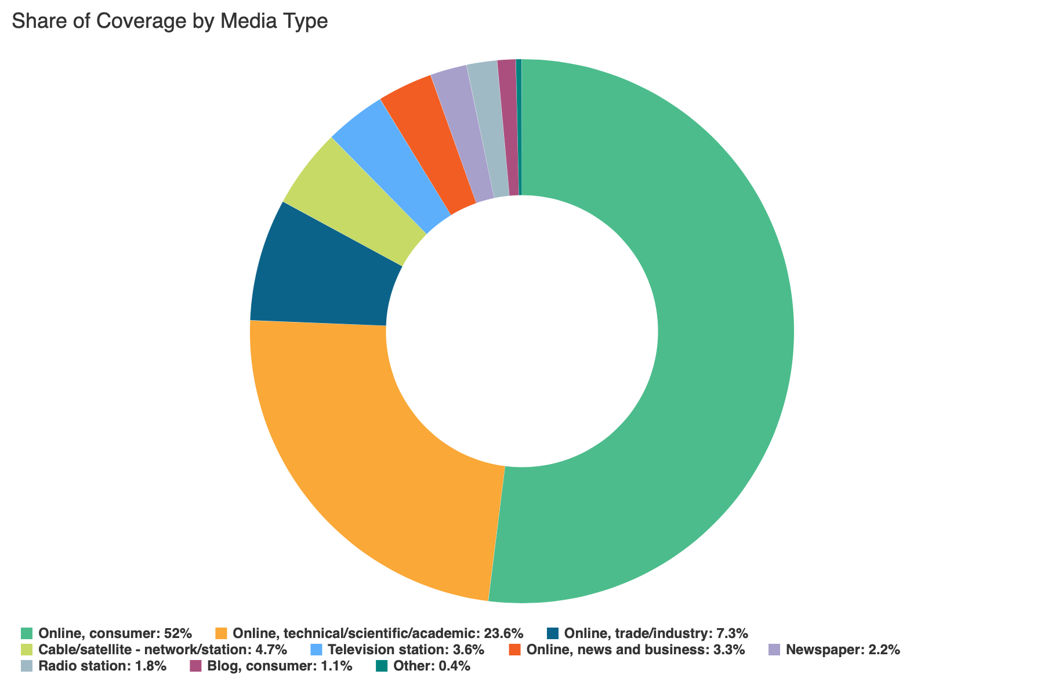

Social Media
SLCC Blog
A total of 9 blog posts were created and place on the SLCC News and Events Page.
12.3 20 Tips to Help You Survive Finals Week
Promoted on SLCC Today, Twitter, Facebook

12.3 Athletes Excited to Compete in New Beach Volleyball Program
Promoted on SLCC Today, Twitter

12.6 EMT Students Receive $11,000 in Scholarships From AT&T
Promoted on SLCC Today, LinkedIn

12.11 For Three Generations of Nurses in One Family, Graduation is Special
Promoted on SLCC Today, Twitter, LinkedIn

12.12 Chemical Society Students Raise Money for Children’s Hospital
Promoted on SLCC Today, Twitter, LinkedIn

12.16 Bookstore’s “Shop By Author” Makes Searching, Finding Titles Easier
Promoted on SLCC Today
12.16 Dream Center: Helping Students From Access to Graduation
Promoted on SLCC Today, Twitter, LinkedIn

12.19 Culinary, Fashion Institutes Collaborate on Unique Creations
Promoted on SLCC Today, Twitter, Facebook

12.20 SLCC, U of U Collaborate on Electric Car Made of Composite Materials
Promoted on SLCC Today, Twitter, LinkedIn

Twitter
Number of tweets: 9
Tweet impressions: 38.5K
Number of mentions: 68
Follower Count: 4115 (+13)
Top Tweet: Top Mention:
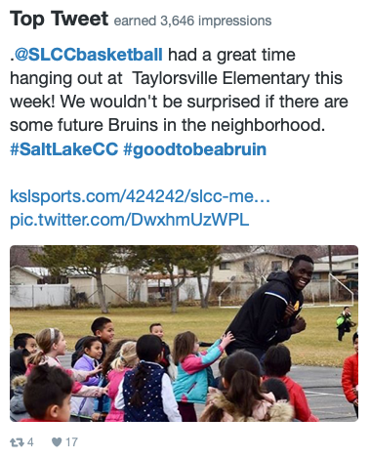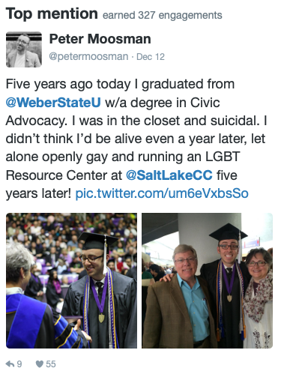

Top Media Tweet:
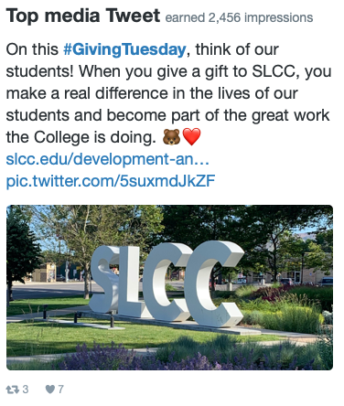
Facebook
Number of posts: 6
Post impressions: 83,113
Page likes: 20,309
Top post:
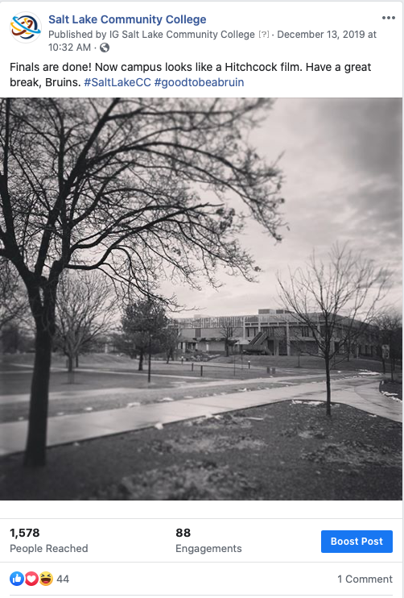

LinkedIn
Number of posts: 3
Page views: 954
Unique visitors: 497
Total followers: 60,842 (-32)
Likes: 134
Comments: 1
Shares: 3
Top Post:
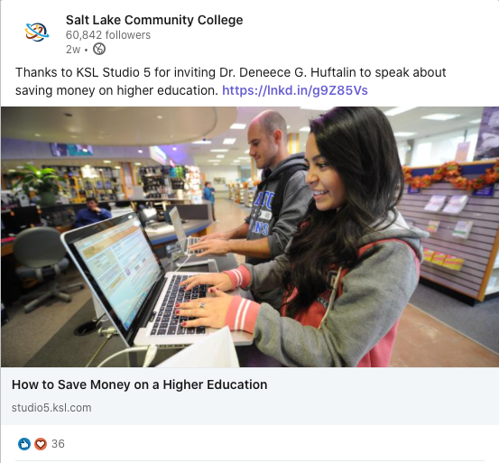

Instagram
Number of posts: 1
Number of stories: 16
Post likes: 138
Total followers: 3017 (+47)
Top post:
