April 2020

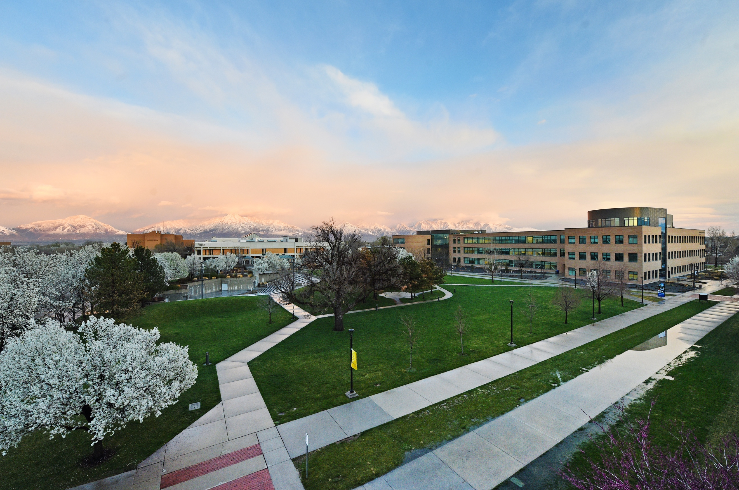

media Report

News Coverage

Summary
521 stories in national and local media. An estimated 5,759,562 people had subscriber access (reach) to these articles with an estimated earned media value of $460,462.34.

Media Advisories

April 24, 2020

SLCC to honor its graduates with special online commencement ceremony (Press Calls, Media Advisory)

April 30, 2020

SLCC Announces Fundraiser for Students During #GivingTuesdayNow (Press Calls, Media Advisory)

Top Stories

April 3, 2020

Former SLCC athletic director Norma Carr receives NJCAA Appreciation Award DESERET.COM
Even more than five years after her retirement, former Salt Lake Community College athletic director Norma Carr’s impact is felt. On Wednesday, she was awarded the National Junior College Athletic Association Appreciation Award for her work in providing “superior contributions to the Association.”

April 3, 2020

Empty Utah: SLCC Redwood Campus ABC4.COM
Places once bustling with activity, now seemingly deserted and desolate, as businesses and schools close their doors amid the COVID-19 pandemic. News Drone 4 captures the quiet Salt lake Community College Redwood Campus.

April 12, 2020

SLCC to offer online-only classes for summer term DESERET.com
Salt Lake Community College will offer only online classes for summer term, which starts May 18. SLCC will also defer a 1.5% tuition increase until the spring 2021 term. For the summer term, the college will waive its online course fee for all classes, including those normally delivered online.

April 20, 2020

Kelly Whited Jones: Utah nurses do too much for too little SLTRIB.com
We are asking too much for too little. Imagine waking up each day weighing the risk of going to work to help sick patients against protecting your own health. Now consider that you are doing it for less pay, less career mobility and less representation in health administration. The professionals on the front lines of this pandemic are overwhelmingly women. In Utah, 89% of nurses and 22% of physicians are women. Nationwide, three-quarters of full-time health workers are women. A 2015 study found that male RNs still out-earn female RNs across specialties and positions, without the pay gap narrowing over time.
April 23, 2020

COVID-19 brings convenience factor to job market ABC4.COM

In the last five weeks, 125,150 Utahns applied for unemployment insurance benefits with the Department of Workforce Services. That’s a lot of people who may be looking for a new line of work post-COVID-19. “You just don’t want to wake up some morning and find out your career is gone, and we are there in some cases,” said Salt Lake Community College Economics Associate Professor Dennis Watson.

April 24, 2020

SLCC to honor graduates with online commencement ceremony ABC4.COM

Salt Lake Community College says it is proud to celebrate its graduates’ “grit and achievement” in an online ceremony posted on the school’s website starting June 26. “Although our commencement ceremony will look different this year, it will never diminish the respect and pride I have in our 2020 graduating class,” said SLCC President Deneece G. Huftalin.

April 28, 2020

SLCC to observe graduation online, in print and with celebration packs mailed to grads DESERET.com
Salt Lake Community College has planned 2020 commencement observances in May and June to honor graduates online, with celebration packages sent to each graduate and a public tribute to be published in Salt Lake’s daily newspapers.
April 28, 2020

Julie Stewart and Leonel Nieto: Not everyone can weather this storm the same way SLTRIB.COM

For many Utahns, the coronavirus pandemic has meant working from home, caring for kids and trying to remain sane when most outlets for fun, recreation and socializing are closed. But this reality is far from universal.

April 29, 2020

SLCC to observe graduation online, in print and with celebration packs mailed to grads

KSL.COM

Salt Lake Community College has planned 2020 commencement observances in May and June to honor graduates online, with celebration packages sent to each graduate and a public tribute to be published in Salt Lake’s daily newspapers.

April 29, 2020

Dual enrollment carries on virtually CCDAILY.COM
In general, community colleges seem to be working well with their high school partners to adapt their courses to a distance learning environment for dual-enrollment students.

April 30, 2020

SLCC announces fundraiser for students during #GivingTuesdayNow UTAHPOLICY.COM
Salt Lake Community College will participate in #GivingTuesdayNow, a special global day of giving during which the college aims to raise $10,000 on May 5 for its students who have been impacted by COVID-19.
Media Coverage Analytics
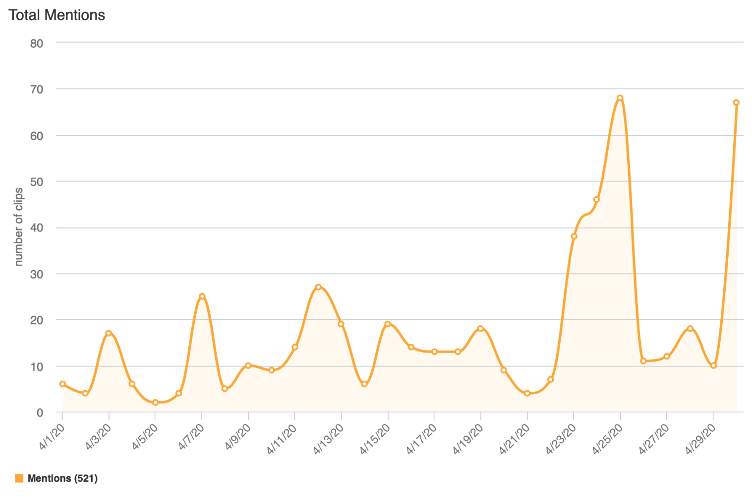

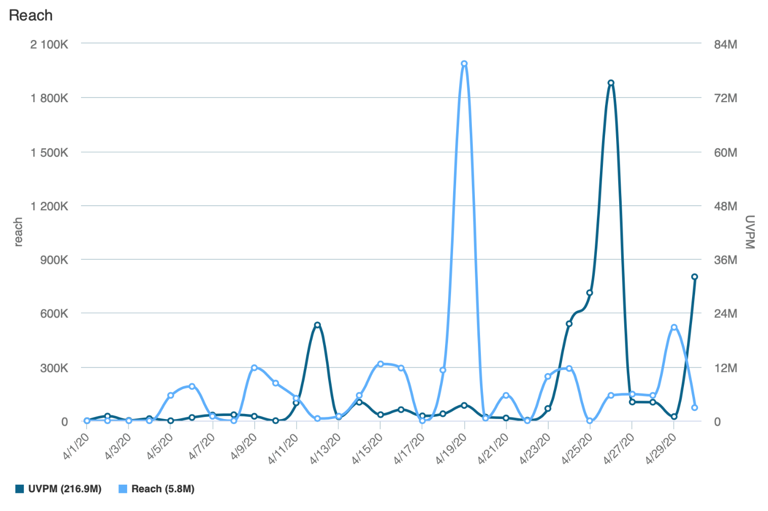
Reach is the Total Number of Unique Viewers/Readers, UVPM is the Total Number of Viewers Across All Social Platforms

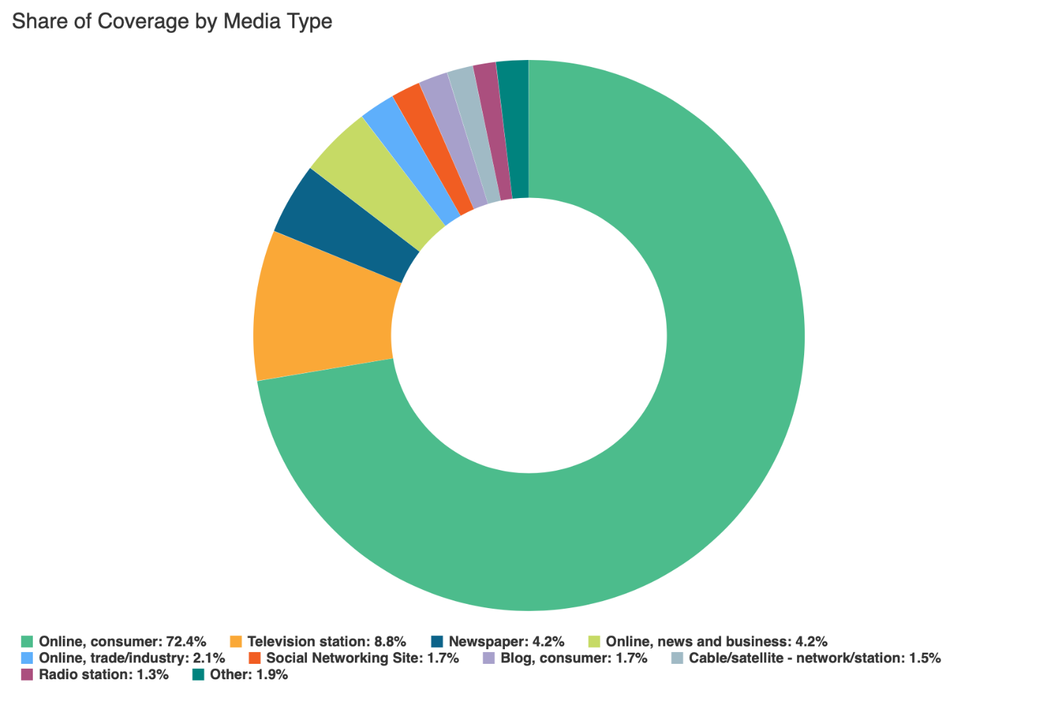

Social Media
SLCC Blog
A total of 32 blog posts were created and placed on the SLCC News and Events Page.
4.2 Softball Athletes Coping with Distance and Life Without Competition
Promoted on Twitter, Facebook, SLCC Today

4.3 The Show Must Go On - Online
Promoted on Twitter, Facebook, SLCC Today

4.3 Former Athletic Director Awarded National Honor
Promoted on Twitter, Facebook, SLCC Today

4.3 Take Part In a Virtual Day of Service
Promoted on Twitter, Facebook, SLCC Today

4.6 All SLCC Summer Courses Will Be Offered Online
Promoted on Twitter, Facebook, SLCC Today

4.6 Professional Development opportunities for the week of April 6–10
Promoted on SLCC Today
4.8 Retirement sessions
Promoted on SLCC Today

4.13 College Donates Supplies, Brainpower to Help Community During Pandemic
Promoted on Twitter, Facebook, LinkedIn, SLCC Today

4.13 Biology Professor Honored for Service, Dedication
Promoted on Twitter, LinkedIn, SLCC Today

4.13 Professional development opportunties for the week of April 13–17
Promoted on SLCC Today

4.13 On Quieted Campuses, Facilities Keeps the Fire Burning
Promoted on Twitter, SLCC Today

4.14 Innovations in Teaching: Culinary Arts
Promoted on Twitter, LinkedIn, SLCC Today

4.14 Innovations in Teaching: Social Media Tools and Strategies
Promoted on Twitter, LinkedIn, SLCC Today

4.15 Faculty Development Opportunities: April 16–17
Promoted on SLCC Today

4.17 Innovations in Teaching: Live Radio Lives On
Promoted on Twitter, LinkedIn, SLCC Today

4.20 SLCC Alumna Wins Prestigious Truman Scholarship
Promoted on Twitter, LinkedIn, SLCC Today

4.20 Benefits Open Enrollment for Full-time Employees
Promoted on SLCC Today

4.20 Benefits Information for Part-time Employees
Promoted on SLCC Today

4.20 Professional Development Opportunities for the week of April 20–24
Promoted on SLCC Today

4.20 Innovations in Teaching: Art Lessons in a Virtual Environment
Promoted on Twitter, LinkedIn, SLCC Today

4.21 Innovations in Teaching: Anatomy and Physiology
Promoted on Twitter, LinkedIn, SLCC Today

4.22 Basketball Ended Abruptly: And A New Way of Life Began
Promoted on Twitter, SLCC Today

4.22 Message to Students from Student Association Senate: Vote in November
Promoted on Facebook, SLCC Today

4.23 Stress-management Tools You Can Use
Promoted on SLCC Today

4.24 College to honor graduates with special online commencement ceremony
Promoted on Twitter, LinkedIn, SLCC Today

4.27 Innovations in Teaching: Transmissions transition to virtual
Promoted on Twitter, LinkedIn, SLCC Today

4.27 Professional Development Opportunities for the Week of April 27–May 1
Promoted on SLCC Today

4.28 Innovations in Teaching: English as a Second Language
Promoted on Twitter, LinkedIn, SLCC Today

4.29 Innovations in Teaching: STEM Tutors
Promoted on Twitter, LinkedIn, SLCC Today

4.29 Masks, Shields Being Offered to SLCC Employees
Promoted on SLCC Today

4.29 SLCC Announces Fundraiser for Students During #GivingTuesdayNow
Promoted on Twitter, SLCC Today

Twitter
Number of tweets: 36
Tweet impressions: 78K
Number of mentions: 272
Follower Count: 4353 (+23)
Top Tweet: Top Mention:

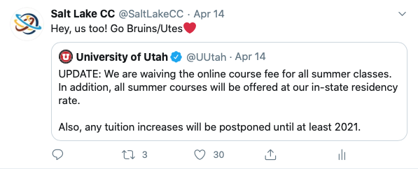
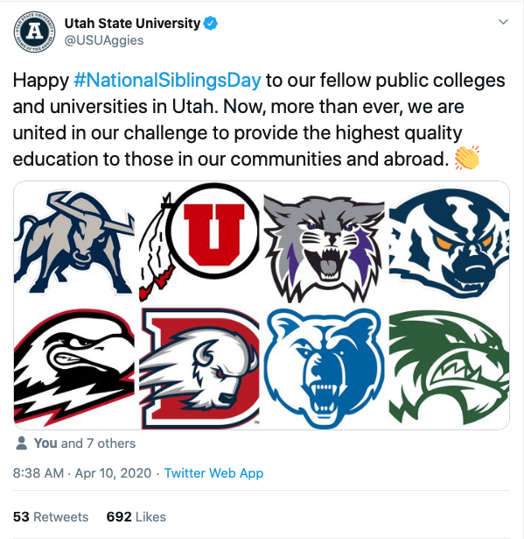
Top Media Tweet:
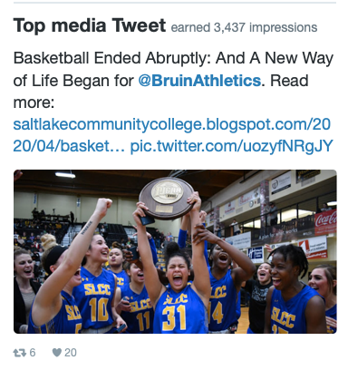

Facebook
Number of posts: 14
Post impressions: 76K
Page likes: 20,734 (+66)
Top post:
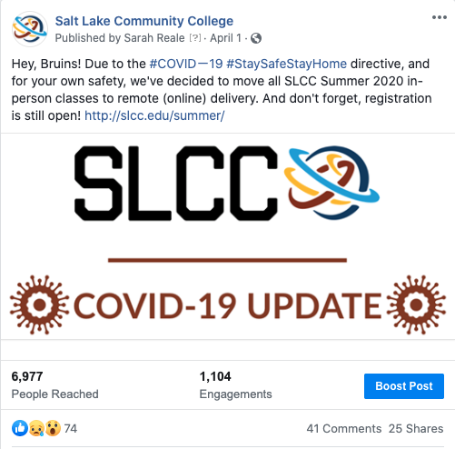

LinkedIn
Number of posts: 8
Page views: 806
Unique visitors: 490
Total followers: 60,650 (-43)
Likes: 103
Comments: 0
Shares: 10
Top Post:
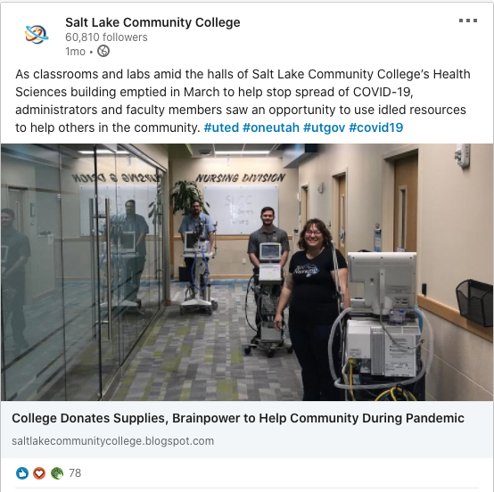

Instagram
Number of posts: 6
Number of stories: 37
Post likes: 502
Total followers: 3465 (+73)
Top post:
