June 2020

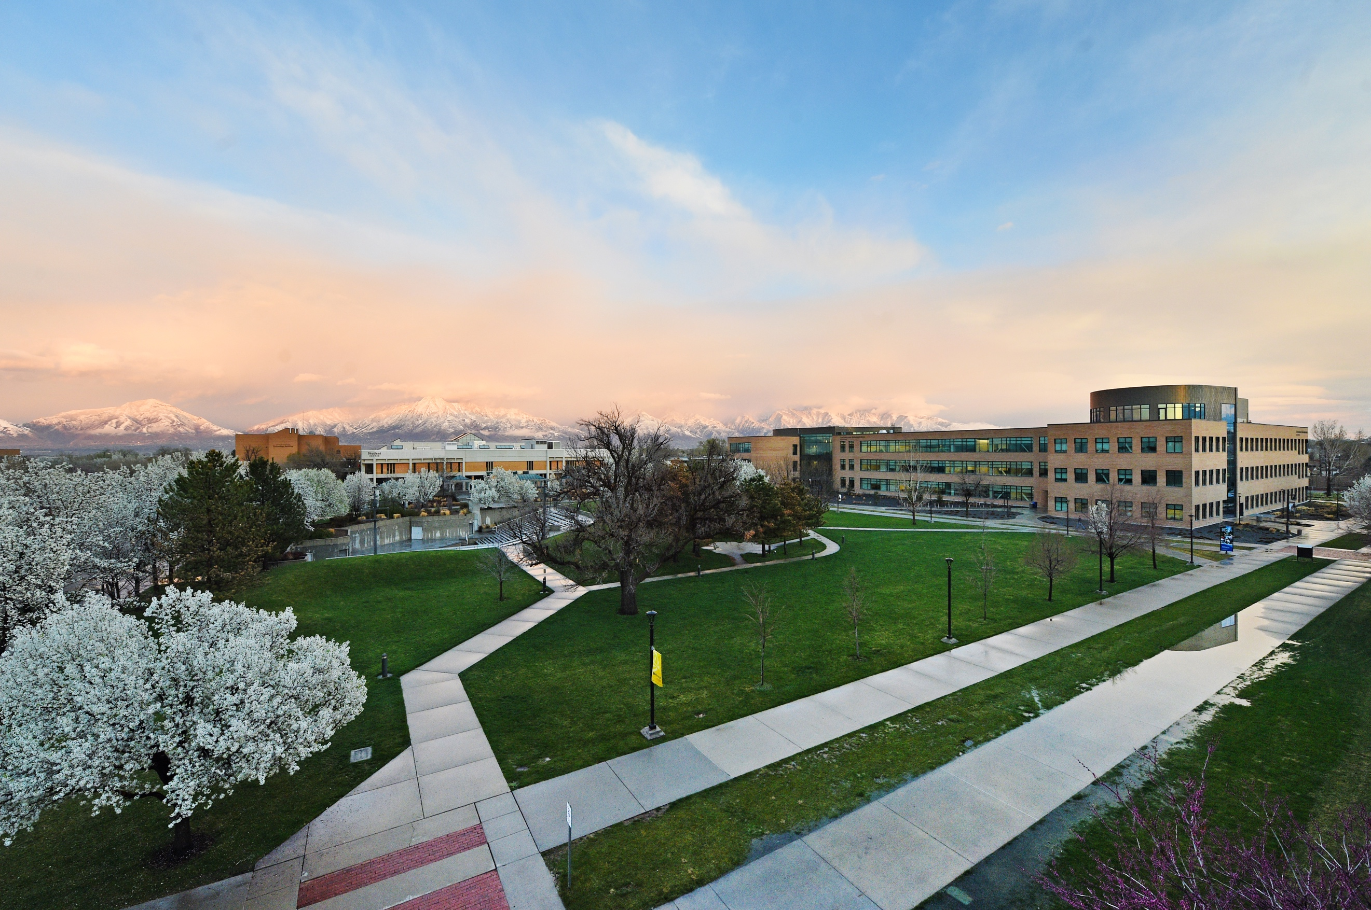

media Report
News Coverage

Summary
437 stories in national and local media. An estimated 5,374,304 people had subscriber access (reach) to these articles with an estimated earned media value of $690,150.74.

Media Advisory

June 26, 2020

With the traditional commencement cancelled because of the COVID-19 pandemic, SLCC moved its ceremony to an online event that featured many of the traditional elements. (Press Calls, Media Advisory)

Top Stories

June 1, 2020

How are Utah's police officers trained on interacting with minority communities? KUTV.COM
Utahns training to become police officers receive 18 hours of community relations and conflict resolution training.
June 10, 2020

Helping children cope with protests and racial violence in the news KUTV.COM
Ardi Ghimire, counselor and licensed clinical social worker, joins us to talk about how to help our children cope with protests and racial violence in the news.

June 15, 2020

Living hand-to-mouth DESERET.com
A young dental assistant feels the range of emotions brought about by the pandemic — and faces its dangers..

June 15, 2020

10 Things You Didn’t Know About Tik Tok Star Jason Clark TVOVERMIND.com
Recently, Jason Clark posted on his Instagram page about going through a near-death experience, while making a video for Tik Tok..
June 16, 2020

NACCE Welcomes Five Colleges to the Everyday Entrepreneur Venture Fund Program Phase II PRLOG.ORG

The National Association for Community College Entrepreneurship (NACCE) is thrilled to announce the acceptance of five institutions into the Everyday Entrepreneur Venture Fund (EEVF) Program Phase II.

June 17 , 2020

SLCC Miller Business Center Helping Small Businesses in Pandemic ABC4.COM

Jim Herrin with Salt Lake Community College speaks with Nicea DeGearing of Good Things Utah today about the small business development center.

June 17, 2020

Kids aren’t immune to heavy topics. Here’s how to approach hard conversations with them KSL.com
The topics of race, free speech, and violence are huge in the news, and our kids aren’t immune to that. They’re seeing what we’re seeing, but they might need some help processing it all.
June 18, 2020

‘Better Every Semester’: How Faculty Use Open Educational Resources to Improve Courses EDSURGE.COM

When Melissa Hardy took over a biology laboratory class at Salt Lake Community College, she inherited a commercial lab manual that left much to be desired.

June 22, 2020

Fire rips through vacant building at Salt Lake Community College

ABC4.COM

Firefighters responded to a large fire that engulfed a vacant building at Salt Lake Community College Monday.

June 22, 2020

Fire burns applied technology facility at Salt Lake Community College DESERET.COM
Fire crews from across Salt Lake County responded to a fire at Salt Lake Community College’s Taylorsville campus Monday that sent up a billowing cloud of smoke visible from around the valley.

June 26, 2020

SLCC Class of 2020 Encouraged During Virtual Commencement Ceremony to Keep their "Souls Aloft" FINANCE.YAHOO.COM
With the traditional commencement cancelled because of the COVID-19 pandemic, SLCC moved its ceremony to an online event that featured many of the traditional elements.

June 29, 2020

Fly fishing and face masks on the Green River MSN.COM
Cori-Alice Holladay inspects her Clemson-orange drift boat from bow to stern. The morning sun is still climbing so her mirrored sunglasses are tucked above the bill of a ball cap.

June 30, 2020

‘Better Every Semester’: How Faculty Use Open Educational Resources to Improve Courses PEOPLE.UIS.EDU
Much of the attention that open educational resources have earned focuses on their low cost. After all, a free or inexpensive alternative to a pricey commercial textbook can make a big difference for students at institutions like Salt Lake Community College, who are “mostly not affluent,” Hardy sayS.

Media Coverage Analytics
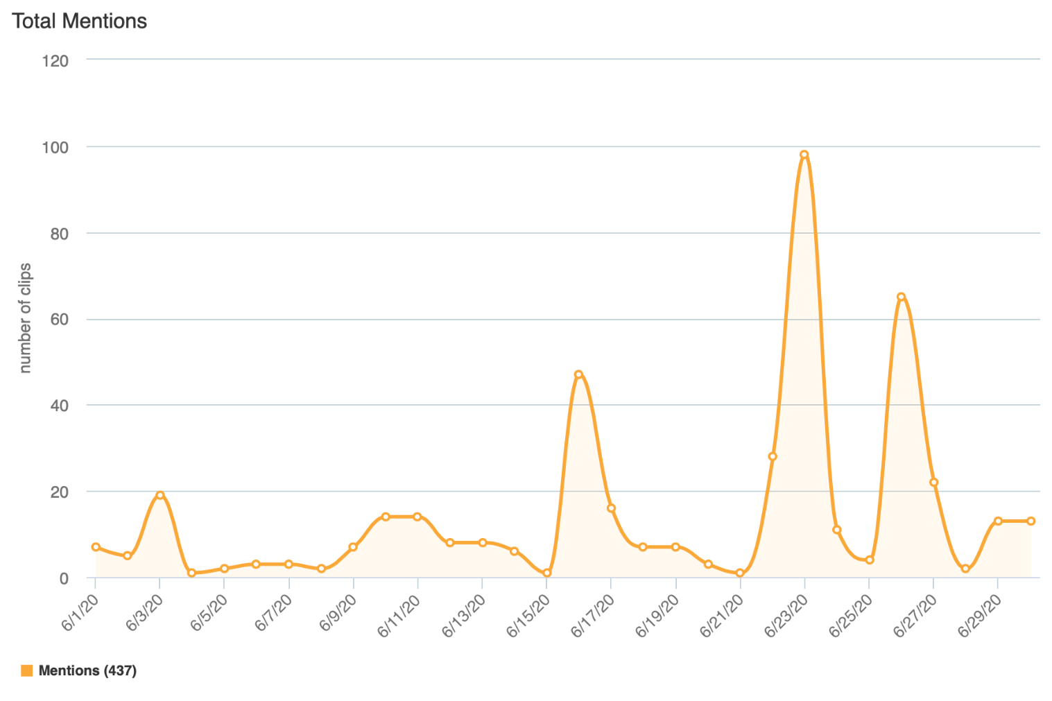

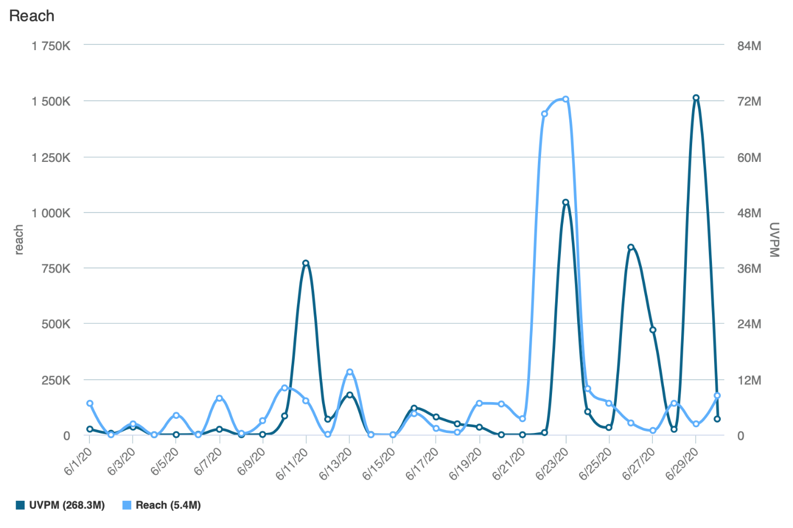
Reach is the Total Number of Unique Viewers/Readers, UVPM is the Total Number of Unique Viewers Across All Social Platforms

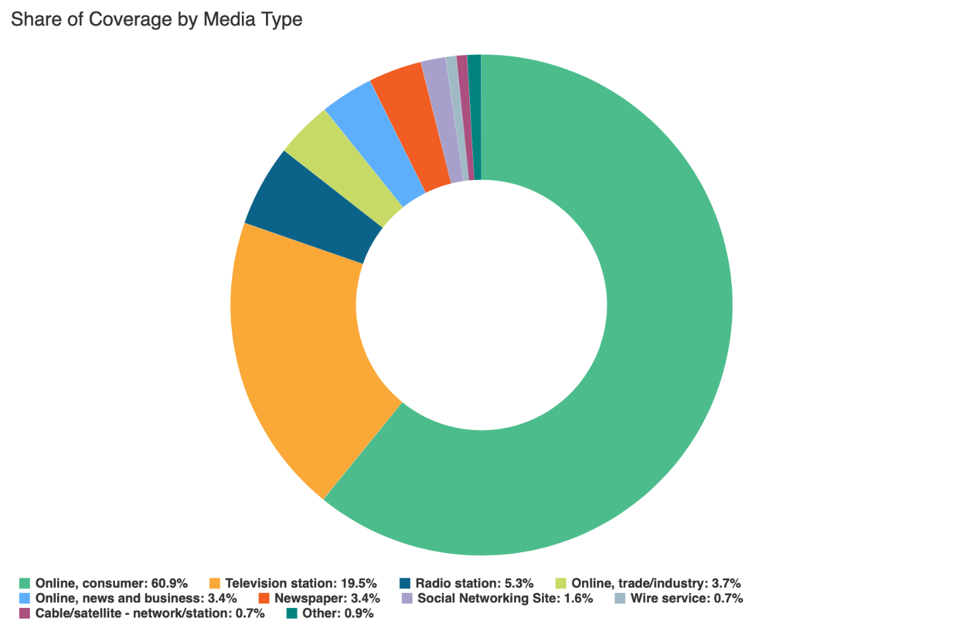

Social Media
SLCC Blog
A total of 19 blog posts were created and placed on the SLCC News and Events Page.
6.1 College Planning for Students on Campuses this Fall
Promoted on Twitter, SLCC Today

6.1 A Message from President Huftalin
Promoted on Twitter, Facebook, SLCC Today

6.1 Faculty Development Opportunities for the Week of June 1–5, 2020
Promoted on SLCC Today

6.1 Professional Development Opportunities for the Week of June 1–5, 2020
Promoted on SLCC Today

6.4 SOLD: Annual Project House Complete, Despite Pandemic
Promoted on Twitter, Facebook, LinkedIn, SLCC Today

6.8 Meet Our Faculty: Perparim Gutaj
Promoted on Twitter, Facebook, LinkedIn, SLCC Today

6.8 Professional Development Opportunities for the Week of June 8–12, 2020
Promoted on SLCC Today

6.15 Signs of Life: Taylorsville Campus
Promoted on Twitter, Facebook, SLCC Today

6.17 Professional Development Opportunities for the week of June 17–24
Promoted on SLCC Today

6.17 Signs of Life: Jordan Campus
Promoted on Twitter, Facebook, SLCC Today

6.18 Meet Our Faculty: Aarti Nakraeet
Promoted on Twitter, Facebook, LinkedIn, SLCC Today

6.23 A Message from President Huftalin Regarding the U.S. Supreme Court's Decision
Promoted on Twitter, Facebook, SLCC Today

6.23 Professional Development Opportunities for the Week of June 24–30
Promoted on SLCC Today

6.25 Signs of Life: Westpointe
Promoted on Twitter, Facebook, SLCC Today

6.25 To Kill A Mockingbird (Almost) Ushers in Reopening of Grand Theatre
Promoted on Twitter, Facebook, SLCC Today

6.26 Signs of Life: Miller Campus
Promoted on Twitter, Facebook, SLCC Today

6.26 Class of 2020 Encouraged During Virtual Commencement Ceremony to Keep their “Souls Aloft”
Promoted on Twitter, Facebook, LinkedIn, SLCC Today

6.30 BSU Event Airs Racial Injustices, Offers Advice for Change
Promoted on Twitter, Facebook, SLCC Today

6.30 Professional Development Opportunities for July 1–July 7, 2020
Promoted on SLCC Today

Twitter
Number of tweets: 37
Tweet impressions: 74K
Number of mentions: 122
Follower Count: 4382 (+31)
Top Tweet: Top Mention:
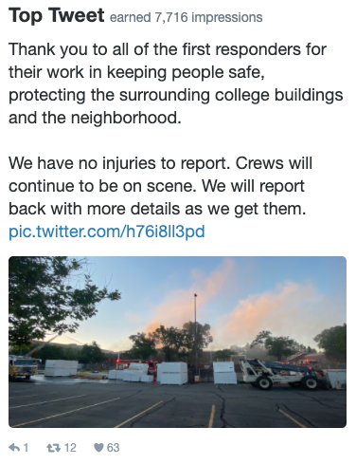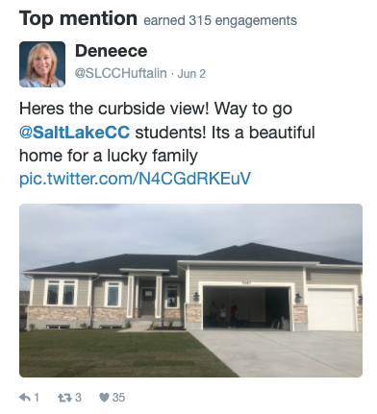

Top Media Tweet:
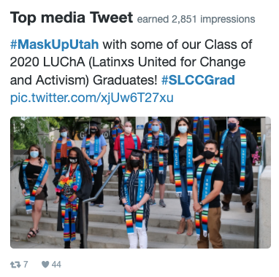

Facebook
Number of posts: 18
Post impressions: 88K
Page likes: 20,859 (+38)
Top post:
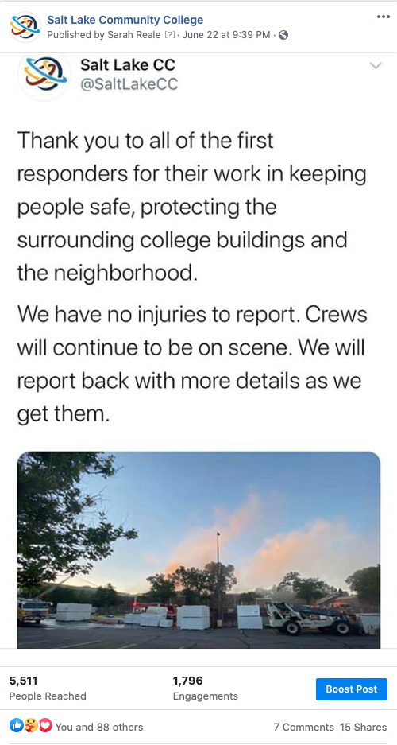

LinkedIn
Number of posts: 2
Page views: 1005
Unique visitors: 615
Total followers: 61,428 (+49)
Reactions: 33
Comments: 5
Shares: 2
Top Post:
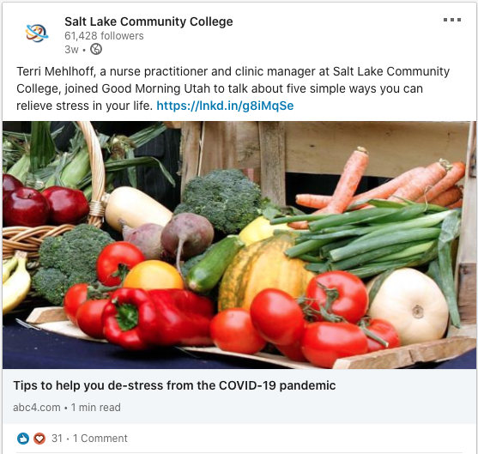

Instagram
Number of posts: 7
Number of stories: 48
Post likes: 806
Total followers: 3629 (+60)
Top post:
